|  |  |  |  |  |
| --- | --- | --- | --- | --- |
|  |  | | |  |
|  |  | | |  |
|  | Second Row Seat Position Control  <<Feature>>  (F003517) | | |  |
|  |  | | |  |
| Document Type | **Feature Document (FD)** | | |  |
| Template Version | **6.1a / FFSD 7.1** | | |  |
| SysML Report Template Version | **O Beta (9/27/2019)** | | |  |
| Document ID | **ffst01.10_featuredocument_sysmlreporttemplate** | | |  |
| Document Location |  | | |  |
| Document Owner | **Diana Aguilar (daguil24@ford.com)** | | |  |
| Document Revision | **FD0** | | |  |
| Document Status | **Draft** | | |  |
| Date Issued | **2021/04/27** | | |  |
| Date Revised | **2021/04/27** | | |  |
| Document Classification | GIS1 Item Number: | **27.60/35** | |  |
| GIS2 Classification: | **Confidential** | |
|  | | | | |
|  | | | | |
| Document Approval | | | | |
| Person | Role | | Email Confirmation | Date |
|  |  | |  |  |
|  |  | |  |  |

**Auto-Generated by MagicDraw**

Printed Copies Are Uncontrolled

# Disclaimer

**This document contains Ford Motor Company Confidential information. Disclosure of the information contained in any portion of this document is not permitted without the expressed, written consent of a duly authorized representative of Ford Motor Company, Dearborn, Michigan, U.S.A.**

**Copyright, Ó 2016 Ford Motor Company**

This document contains information developed and accumulated by and for FORD MOTOR COMPANY. As such, it is a proprietary document, which, if disseminated to unauthorized persons, would provide others with restricted information, data, or procedures not otherwise available, exposing the FORD MOTOR COMPANY to potential harm.

Employees and suppliers having custody of this specification or authorized to use it must be cognizant of its proprietary nature and ensure that the information herein is not made available to unauthorized persons.

FORD MOTOR COMPANY reserves the right to protect this work as an unpublished copyrighted work in the event of an inadvertent or deliberate unauthorized publication. FORD MOTOR COMPANY also reserves its rights under copyright laws to protect this work as a published work.

This document or portions thereof shall not be distributed outside FORD MOTOR COMPANY without prior written consent. Refer all questions concerning disclosure to the author(s) or to any duly authorized representative of Ford Motor Company.

# Contents

1.1.2 Decomposition of Functional Safety Requirement 13

Disclaimer 22

Contents 23

2 Introduction 26

2.1 Document Purpose 26

2.2 Document Scope 26

2.3 Document Audience 26

2.3.1 Stakeholder List 26

2.4 Document Organization 26

2.4.1 Document Context 26

2.4.2 Document Structure 27

2.5 Document Conventions 27

2.5.1 Requirements Templates 27

3 Feature Overview 28

3.1 Purpose and Description of Feature 28

3.2 Feature Variants 28

3.2.1 Regions & Markets 29

3.3 Input Requirements 29

3.3.1 Legal Requirements 30

3.3.2 Trustmark Requirements 30

3.3.3 Industry Standards 30

3.3.4 Attribute Requirements 30

3.4 Lessons Learned 30

3.5 Assumptions 31

3.6 References 31

3.6.1 Ford Documents 32

3.6.2 External Documents and Publications 32

3.7 Glossary 33

3.7.1 Parameters / Values 33

4 Feature Context 34

4.1 Feature Context Diagram 34

4.2 List of Influences 34

5 Feature Modeling 36

5.1 Operation Modes and States 36

5.2 Use Cases 38

5.2.1 Use Case Diagram 38

5.2.2 Actors 39

5.2.3 Use Case Descriptions 39

5.3 Driving and Operation Scenarios 43

5.4 Decision Tables 45

6 Feature Requirements 46

6.1 Functional Requirements 46

6.1.1 Error Handling 47

6.2 Non-Functional Requirements 47

6.2.1 Safety 47

6.2.2 Security 47

6.2.3 Reliability 47

6.3 HMI Requirements 47

6.4 Other Requirements 48

6.4.1 Design Requirements 48

6.4.2 Manufacturing Requirements 48

6.4.3 Service Requirements 48

6.4.4 After Sales Requirements 48

6.4.5 Process Requirements 48

6.4.6 Uncategorized Requirements 49

7 Functional Safety 50

7.1 System Behaviors for HARA 50

7.2 Safety Assumptions 50

7.3 Safety Goals 51

7.4 Functional Safety Requirements 53

7.4.1 Safety Goal: 53

7.4.2 Derivation of Functional Safety Requirements on Assumptions 55

7.5 ASIL Decomposition of Functional Safety Requirements 56

8 Architecture 57

8.1 Functional Architecture 57

8.1.1 List of Functions 57

8.2 Logical Architecture 58

8.2.1 Logical Interfaces 59

9 Open Concerns 61

10 Revision History 62

11 Appendix 63

11.1 Definitions 63

11.2 Abbreviations 63

**List of Figures**

Figure 1. 12

Figure 2: 28

Figure 3: - 28

Figure 4: 34

Figure 5: 36

Figure 6: 38

Figure 7:  55

Figure 8: 57

Figure 9: 58

**List of Tables**

Table 1: Features described in this FD 26

Table 2: Feature Variants 29

Table 3: Regions & Markets 29

Table 4: Ford internal Documents 32

Table 5: Ford internal Documents *(not specified in SysML model)* 32

Table 6: External documents and publications 32

Table 7: External documents and publications *(not specified in SysML model)* 33

Table 8: Parameters / Values used in this document *(Not supported by MagicDraw report generation)* 33

Table 9: List of Influences 35

Table 10: Operation Modes and States on 36

Table 11: Transitions between Operation Modes and States on 38

Table 12: List of Actors 39

Table 13: System Behaviors for HARA 50

Table 14: Functional Safety Assumptions 51

Table 15: Functional Safety Goals 53

Table 16: List of Functions 58

Table 17: List of Functions on 58

Table 18: Feature Interactions 59

Table 19: Feature Interactions on 59

Table 20: Open Concerns *(Not supported by MagicDraw report generation)* 61

Table 21: Definitions used in this document 63

Table 22: Abbreviations used in this document 64

# Introduction

## Document Purpose

A Feature Document (FD) document specifies **what** the feature shall do and how it shall behave from customer perspective. It should also provide reasoning and background **why** we have the feature in the vehicle.

The FD also serves as an Item Definition as defined by ISO26262 for those features, which follow the Ford Functional Safety process.

To get more information about the concept of feature, function and component level abstraction refer to the [Ford RE Wiki](http://wiki.ford.com/display/RequirementsEngineering/Requirements+Engineering+for+SW+Enabled+Features). For details on the Ford Functional Safety (ISO26262) process refer to the [Ford Functional Safety Sharepoint](https://pd3.spt.ford.com/sites/GlobalFunctionalSafety/Pages/default.aspx).

## Document Scope

This Feature Document (FD) specifies the following features:

|  |  |  |  |
| --- | --- | --- | --- |
| **Feature ID** | **Feature Name** | **Owner** | **Reference** |
| F003517 | Second Row Seat Position Control  (Program(s): CX747 (GE2 Platform)) | Diana Aguilar (daguil24@ford.com) |  |

Table 1: Features described in this FD

## Document Audience

The FD is written by the feature owner of Diana Aguilar (daguil24@ford.com). All Stakeholders, i.e., all people who have a valid interest in the feature should read and, if possible, review the FD. It needs to be guaranteed, that all stakeholders have access to the currently valid version of the FD.

### Stakeholder List

For the latest list of stakeholder of the feature and their influence refer to <Put VSEM Link here>.

|  |  |  |  |  |
| --- | --- | --- | --- | --- |
| **Name** | **CDSID** | **Contact Info** | **Role** | **Stakeholder Group** |
| John Doe |  |  | Model Architect | Systems Engineer |

## Document Organization

### Document Context

Refer to the [Specification Structure page](http://wiki.ford.com/display/RequirementsEngineering/Specification+templates) in the [Ford RE Wiki](http://wiki.ford.com/display/RequirementsEngineering/Requirements+Engineering+for+SW+Enabled+Features) to understand how the FD relates to other Ford Requirements Documents and Specifications.

### Document Structure

The structure of this document is explained below:

**Section 1** – Introduction how to use this document including responsibilities and requisite documents. Explains the terminology. Gives a clarification of the definitions, concepts and abbreviations used in the document.

**Section 2** – Feature Description. States briefly the background and the purpose of the feature, feature variants and corresponding regions and markets. Also includes input requirements, assumptions and constraints.

**Section 3** – Feature Context describes all external entities, which have an influence on the feature.

**Section 4** – Feature Modeling. Contains Use Case, Driving Scenarios, State Charts to describe the functional behavior of the feature.

**Section 5** – Safety. Lists System Behaviors and Safety Goals of the feature.

**Section 6** – Feature Requirements. Lists functional and non-functional requirements of the feature.

**Section 7** – Architecture. Shows the coarse architecture, which the feature requirements are deployed to. Describes the elements and the boundary of the feature as well as the decomposition and distribution of associated functions.

**Section 8** – List of Open Concerns

**Section 9** – Document Change History including a list of new or modified requirements. The requirements in this document are tagged, and this section contains different types of tables listing all, new, or changed requirements by their title and page no.

**Section 10** – Appendix

## Document Conventions

### Requirements Templates

Each requirement, use case or scenario in this specification shall follow the corresponding template given in the document template *Specification_Macros.dotm* at [RE Wiki - Specification Templates](http://wiki.ford.com/display/RequirementsEngineering/Specification+templates?src=contextnavpagetreemode).

#### Identification of requirements

#### Requirements Attributes

The templates provided by *Specification_Macros.dotm* define a list of attributes for each requirement. This helps to classify the requirement. The attributes are explained at [RE Wiki - Requirements Attributes](http://wiki.ford.com/display/RequirementsEngineering/Requirements+Attributes?src=contextnavpagetreemode).

## References

### Ford Documents

List here all Ford internal documents, which are directly related to the feature.

| **Reference** | **Title** | **Doc. ID** | **Document Location** | **Revision** |
| --- | --- | --- | --- | --- |
| Ford GIS Standard | Ford GIS Standard |  |  |  |

Table 4: Ford internal Documents

### External Documents and Publications

The list of external documents could include books, reports and online sources.

| **Reference** | **Document / Publication** | **Document Location** |
| --- | --- | --- |
| IEEE Std 1012-2004 IEEE Standard for Software Verification and Validation |  |  |
| ISO/IEC 19500-2:2003 | Information technology -- Open Distributed Processing -- Part 2 |  |
| UML Testing Profile (UTP), v1.2 |  |  |
| Wikipedia |  |  |

Table 6: External documents and publications

## Glossary

See Appendix for Definitions and Abbreviations.

### Parameters / Values

| **Name** | **Description** | **Range / Resolution** |
| --- | --- | --- |

Table 8: Parameters / Values used in this document

# Feature Overview

## Purpose and Description of Feature

The Second Row Seat Position Control feature is responsible for the following:

1) Power Pitch/Slide Easy Entry/Exit

2) Second row seat calf rest travel

3) Second row seat fore/aft travel

4) Second row seat recline/incline

5) Second row seat lumbar

## Feature Variants

|  |  |  |
| --- | --- | --- |
| **Variant Name** | **Variant Description** | **Remarks** |
| **Variant 1** | Variant 1 of the Second Row Seat Position Control feature is responsible for the following:  1) Power Pitch/Slide Easy Entry/Exit  2) Second row seat calf rest travel  3) Second row seat fore/aft travel  4) Second row seat recline/incline |  |
| **Variant 2** | Variant 2 of the Second Row Seat Position Control feature is responsible for the following:  1) Power Pitch/Slide Easy Entry/Exit  2) Second row seat fore/aft travel  3) Second row seat recline/incline  4) Second row seat lumbar |  |

Table 2: Feature Variants

### Regions & Markets

|  |  |  |  |  |  |  |
| --- | --- | --- | --- | --- | --- | --- |
| **Market /**  **Region**  Variant Name | **North America** | **South America** | **Europe** | **Middle East/Africa** | **Asia / Pacific** | **China** |
| **Variant 1** | Mandatory | No | No | No | No | Mandatory |
| **Variant 2** | Mandatory | No | No | No | No | Mandatory |

Table 3: Regions & Markets

## Input Requirements

### Legal Requirements

* : Compliance with FMVSS207
  + The Feature shall comply with FMVSS207.
* : Compliance with FMVSS210
  + The Feature shall comply with FMVSS210.

### Trustmark Requirements

No Trustmark Requirements specified.

### Industry Standards

* : ISO 26262
  + The system shall be developed according to Ford's implementation of Functional Safety.
* : PPSEEE Power Mode
  + The feature shall be identical to the power mode specified for the driver seat module - [FS-MU5T-14C030-AAH].

### Attribute Requirements

#### : Comfort Adjustments

* + The vehicle shall allow the user's needs to be met for comfort in the SRS.
  + **Rationale:** To allow the user to make comfort adjustments on the second row seat.

#### : Ingress/Egress Access

* + The vehicle shall provide enough space between the SRS and the 3rd Row Seat to allow access to the 3rd Row Seat.
  + **Rationale:** To provide enough space to allow access to the third row seat.

## Lessons Learned

No lessons learned specified.

## Assumptions

No Assumptions specified.

# Feature Context

## Feature Context Diagram

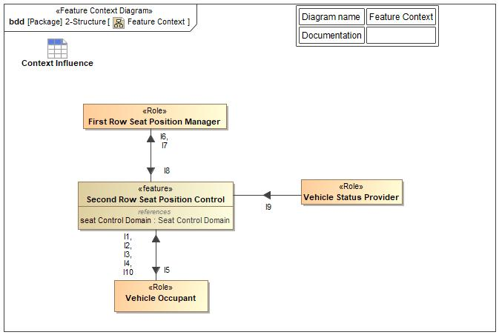

Figure 4: Feature Context

## List of Influences

|  |  |  |
| --- | --- | --- |
| **ID** | **External Entity** | **Influence Description** |
| I1 | Vehicle Occupant To Second Row Seat Position Control | This information item (IngressEgressRequest) is the input from the "User" to activate the Power Pitch/Slide Easy Entry/Exit functionality in order to ingress/egress the 3rd row seat |
| I2 | Vehicle Occupant To Second Row Seat Position Control | This information item (ComfortSeatPositionRequest) represents the seat comfort commands that the user will select to move the seats. |
| I3 | Vehicle Occupant To Second Row Seat Position Control | This information item (IngressEgressAcknowledgement) is the input from the "User" to indicate that the ingress/egress of the 2nd row seat was completed. This will trigger the 2nd row seat to return to a drivable position. |
| I4 | Vehicle Occupant To Second Row Seat Position Control | This information item (UserTerminatesPitchSlide) in the input from the "User" to terminate the PPSEEE Pitch/Slide Process or the PPSEEE Return Process. |
| I5 | Second Row Seat Position Control To Vehicle Occupant | This information item (UserNotification) notifies the "User" of any inaction or termination in the PPSEEE Pitch/Slide Process or the PPSEEE Return Process. |
| I6 | Second Row Seat Position Control To First Row Seat Position Manager | This information item (FirstRowStimuliRequest) requests that the front seat (that is in front of the second row seat that is being requested to move for easy entry/exit) needs to incline to an upright position (if not already) to make room for second row seat to pitch forward. |
| I7 | Second Row Seat Position Control To First Row Seat Position Manager | This information item (FirstRowSeatReset) requests that the first row seat be returned to the "Initial" position. |
| I8 | First Row Seat Position Manager To Second Row Seat Position Control | This information item (FrontSeatPosition) from the front seat informs the second row seat of the fore/aft position of the front row seat track, as well as the incline/recline position of the front row seat track. |
| I9 | Vehicle Status Provider To Second Row Seat Position Control | This information item (VehicleStatus) represents the following:  1) Transmission Status: which gear the transmission of the vehicle is in; namely, PARK, DRIVE, NEUTRAL, or REVERSE?  2) Vehicle Speed: What the current speed of the vehicle is in.  3) IgnitionStatus: Which state the ignition of the vehicle is in; namely, OFF, ACC, RUN, or START. |
| I10 | Vehicle Occupant To Second Row Seat Position Control | This information item (SeatID) represents which seat is being requested to move. |

Table 9: List of Influences

# Feature Modeling

## Operation Modes and States

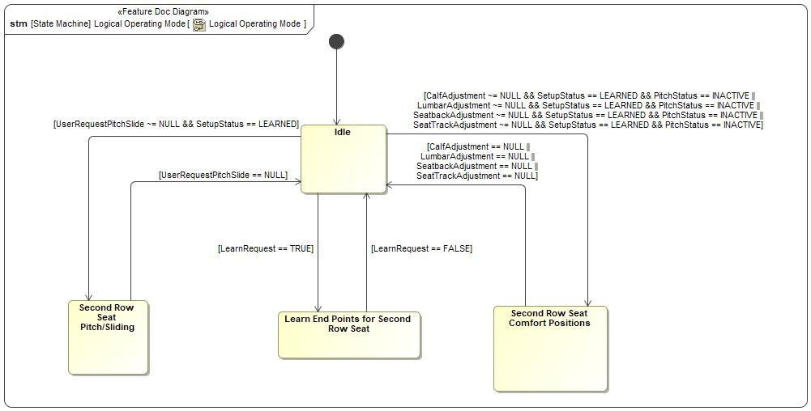

Figure 5: Logical Operating Mode

|  |  |  |
| --- | --- | --- |
| **State** | **Description** | **Requirements Reference** (optional) |
| Idle | No action is occurring. |  |
| Learn End Points for Second Row Seat | The feature will be able to learn the end points. |  |
| Second Row Seat Comfort Positions | The feature will be able to control the comfort settings. |  |
| Second Row Seat Pitch/Sliding | The feature will be able to control the pitch/slide process. |  |

Table 10: Operation Modes and States on Logical Operating Mode

|  |  |  |  |  |
| --- | --- | --- | --- | --- |
| **Transition ID** | **Source** | **Destination** | **Description** | **Requirements Reference**  (optional) |
| T1 |  |  |  |  |
| T2 | Idle | Second Row Seat Pitch/Sliding | Guard: UserRequestPitchSlide ~= NULL && SetupStatus == LE... |  |
| T3 | Learn End Points for Second Row Seat | Idle | Guard: LearnRequest == FALSE |  |
| T4 | Idle | Second Row Seat Comfort Positions | Guard: CalfAdjustment ~= NULL && SetupStatus == LEARNED &... |  |
| T5 | Idle | Learn End Points for Second Row Seat | Guard: LearnRequest == TRUE |  |
| T6 | Second Row Seat Pitch/Sliding | Idle | Guard: UserRequestPitchSlide == NULL |  |
| T7 | Second Row Seat Comfort Positions | Idle | Guard: CalfAdjustment == NULL || LumbarAdjustment == NULL... |  |

Table 11: Transitions between Operation Modes and States on Logical Operating Mode

## Use Cases

### Use Case Diagram

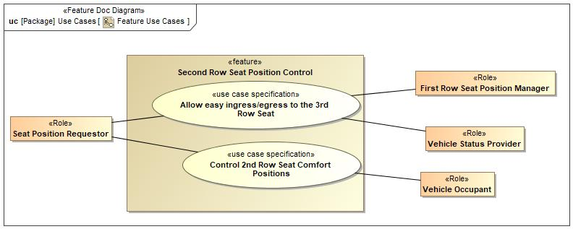

Figure 6: Feature Use Cases

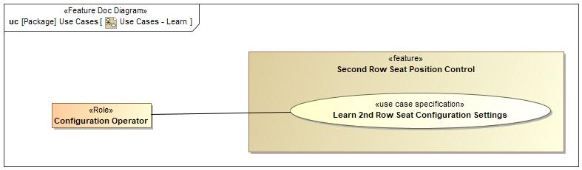

Figure 6: Use Cases - Learn

### Actors

| **Actor** | **Description** |
| --- | --- |
| Configuration Operator | This will be who is requesting the learning of the seat positions for the Second Row Seat Position Control feature. |
| First Row Seat Position Manager |  |
| Seat Position Requestor |  |
| Vehicle Occupant | This will be the person making the request of the Second Row Seat Position Control feature. |
| Vehicle Status Provider | Vehicle Status Provider will provide the following:  1) Transmission Status |

Table 12: List of Actors

### Use Case Descriptions

###UC_F_FRS_00001### Control 2nd Row Seat Comfort Positions

|  |  |  |
| --- | --- | --- |
| **Actors** | Primary | Vehicle Occupant |
| Secondary |  |
| **Subject** |  | Second Row Seat Position Control |
| **Description** |  | The "Control 2nd Row Seat Comfort Positions" Use Case is to provide the User to be able to adjust the comfort seats of the requested SRS. |
| **Preconditions** | PreC1 | Second Row Seat of the requested action needs to be in a latched position. |
| PreC2 | Second Row Seat of the requested action shall not be in the minimum/maximum position of the desired movement. |
| **Triggers** | T1 | Receive SeatPositionCommand |
| **Main Flow Description** |  | User requests seat comfort positions. |
| **Main Flow** | M1 | User requests a 2nd row seat to move to a desired comfort position. |
| M2 | The requested 2nd row seat moves to the requested comfort position. |
| **Alternative Flow Description** |  | N/A |
| **Alternative Flow Steps** | A1 | N/A |
| **Postconditions** | PostC1 | After the user stops requesting a comfort setting, the requested SRS is in the desired comfort position. |

###UC_F_FRS_00002### Allow easy ingress/egress to the 3rd Row Seat

|  |  |  |
| --- | --- | --- |
| **Actors** | Primary | Vehicle Occupant |
| Secondary | Vehicle Status Provider |
| Secondary | First Row Seat Position Manager |
| **Subject** |  | Second Row Seat Position Control |
| **Description** |  | The "Allow easy ingress/egress to the 3rd Row Seat" Use Case is to provide the User easy access to the TRS. The Use Case requests the forward and return (rearward) movement of the requested SRS. |
| **Preconditions** | PreC1 | Vehicle status is idle. |
| **Triggers** | T1 | Receive IngressEgressRequest |
| **Main Flow Description** |  | User requests access to the 3rd row seat. Once the user has access, User requests the seat to go back to original, "Enabled" position. |
| **Main Flow** | M1 | User Requests Access to 3rd Row Seat |
| M2 | Vehicle status is checked by feature. |
| M3 | First Row Seat will begin to move, if necessary |
| M4 | Requested 2nd Row Seat Moves to Allow Access |
| M5 | User accesses 3rd row seat. |
| M6 | User acknowledges completion of task by requesting the originally selected 2nd Row Seat returns to "Enabled" position. |
| M7 | Requested 2nd Row Seat Moves to "Reset" position. |
| M8 | First Row Seat returns to "Initial" position, if necessary. |
| **Alternative Flow Description** |  | N/A |
| **Alternative Flow Steps** | A1 | N/A |
| **Postconditions** | PostC1 | After the SRS has been pitched forward, the SRS is returned to the seated and latched position. |
| PostC2 | The FRS returns to its "Initial" Position. |

###UC_F_FRS_00003### Learn 2nd Row Seat Configuration Settings

|  |  |  |
| --- | --- | --- |
| **Actors** | Primary | Configuration Operator |
| Secondary |  |
| **Subject** |  | Second Row Seat Position Control |
| **Description** |  |  |
| **Preconditions** |  |  |
| **Triggers** | T1 | Receive LearnRequest |
| **Main Flow Description** |  | Operator requests Learn Cycle |
| **Main Flow** | M1 | User requests to learn 2nd row seat end-point positions. |
| M2 | The 2nd row seat comfort and pitch positions will move forward and backward to determine the end-points. |
| **Alternative Flow Description** |  | N/A |
| **Alternative Flow Steps** | A1 | N/A |
| **Postconditions** | PostC1 | User will be notified if end points have been learned or not. |

## Driving and Operation Scenarios

## Decision Tables

*Not supported by MagicDraw report generation.*

# Feature Requirements

## Functional Requirements

###R_F_FRS_00001### 2nd Row PPSEEE "Enabled" Position

The Second Row Seat Position Control Feature shall ensure the 2nd row seat be in the "Enabled" Position for pitch/slide of the 2nd row seat for the provided "SeatID".

|  |  |  |  |  |  |  |  |
| --- | --- | --- | --- | --- | --- | --- | --- |
| Requirement ID: | | | | | | | |
| **Rationale** | To be in the proper position in order to begin pitch/slide of the 2nd Row Seat. | | | | | | |
| **Acceptance Criteria** | Per user request of a 2nd row seat pitch/slide forward, 2nd row seat moves to a predefined position before the 2nd row seat begins to pitch/slide forward. | | | | | | |
| **Notes** | The 2nd Row Seat shall go to the "Enabled" Position before beginning a pitch/slide event. | | | | | | |
| **Source** | Diana Aguilar | | | | | **Owner** | Diana Aguilar |
| **Source Req.** |  | | | | | **V&V Method** | Visual inspection of the 2nd row seat location before pitch/slide begins. |
| **Type** |  | | | **Priority** | 1 - High | **Status** | In-Progress |
| [Req. Template](http://wiki.ford.com/display/RequirementsEngineering/Requirements+Attributes) Version | | 6.0 | End of Requirement | | | | |

###R_F_FRS_00002### Pitch Status

The Pitch process shall provide the status of the pitch to the Comfort System.

|  |  |  |  |  |  |  |  |
| --- | --- | --- | --- | --- | --- | --- | --- |
| Requirement ID: | | | | | | | |
| **Rationale** | To disable comfort seat control what the SRS is in the pitch/slide process. | | | | | | |
| **Acceptance Criteria** |  | | | | | | |
| **Notes** | This will provide the status of the pitch and slide for the 2nd row PPSEEE. | | | | | | |
| **Source** | Diana Aguilar | | | | | **Owner** | Diana Aguilar |
| **Source Req.** |  | | | | | **V&V Method** |  |
| **Type** |  | | | **Priority** | 1 - High | **Status** | In-Progress |
| [Req. Template](http://wiki.ford.com/display/RequirementsEngineering/Requirements+Attributes) Version | | 6.0 | End of Requirement | | | | |

###R_F_FRS_00003### Vehicle Status

The Second Row Seat Position Control Feature shall provide the PPSEEE Pitch/Slide Process only when the vehicle is in Idle.

|  |  |  |  |  |  |  |  |
| --- | --- | --- | --- | --- | --- | --- | --- |
| Requirement ID: | | | | | | | |
| **Rationale** | Providing the feature under other conditions may cause safety issues or improper vehicle operations. | | | | | | |
| **Acceptance Criteria** | Per user request of the pitch/slide forward action, the vehicle shall only pitch/slide forward if the vehicle is in the desired conditions. | | | | | | |
| **Notes** | The user shall only be able to initiate the PPSEEE Pitch/Slide Process when Gear Selection is in PARK. | | | | | | |
| **Source** | Diana Aguilar | | | | | **Owner** | Diana Aguilar |
| **Source Req.** |  | | | | | **V&V Method** | Visual inspection of the 2nd Row Seat only moving during the desired vehicle conditions and not moving when the desired vehicle conditions are not met. |
| **Type** |  | | | **Priority** | 1 - High | **Status** | In-Progress |
| [Req. Template](http://wiki.ford.com/display/RequirementsEngineering/Requirements+Attributes) Version | | 6.0 | End of Requirement | | | | |

###R_F_FRS_00004### Select Desired Seat

The "Second Row Seat Position Control" Feature shall control the seat requested by the user.

|  |  |  |  |  |  |  |  |
| --- | --- | --- | --- | --- | --- | --- | --- |
| Requirement ID: | | | | | | | |
| **Rationale** | To indicate which seat is being requested, the driver side or the passenger side | | | | | | |
| **Acceptance Criteria** | Per user request, action will be performed on the appropriate seat. | | | | | | |
| **Notes** | This indicates which seat is being requested, the driver side or the passenger side. | | | | | | |
| **Source** | Diana Aguilar | | | | | **Owner** | Diana Aguilar |
| **Source Req.** |  | | | | | **V&V Method** | Visual inspection of the appropriate seat moving. |
| **Type** |  | | | **Priority** | 1 - High | **Status** | In-Progress |
| [Req. Template](http://wiki.ford.com/display/RequirementsEngineering/Requirements+Attributes) Version | | 6.0 | End of Requirement | | | | |

###R_F_FRS_00005### 1st Row PPSEEE "Enabled" Position

The Second Row Seat Position Control Feature shall ensure the 1st row seat is in the "Enabled" Position for pitch/slide of the 2nd row seat for the provided "SeatID".

|  |  |  |  |  |  |  |  |
| --- | --- | --- | --- | --- | --- | --- | --- |
| Requirement ID: | | | | | | | |
| **Rationale** | To guarantee the 2nd row seat pitches/slides without hinderance. | | | | | | |
| **Acceptance Criteria** | Per user request of a 2nd row seat pitch/slide forward, 1st row seat moves to a predefined position to allow the 2nd row seat to pitch/slide forward. | | | | | | |
| **Notes** | If the 1st row seat is not in the proper position, the 2nd row seat will request it to move to the "Enabled" Position. | | | | | | |
| **Source** | Diana Aguilar | | | | | **Owner** | Diana Aguilar |
| **Source Req.** |  | | | | | **V&V Method** | Visual inspection of the 1st row seat location before the pitch/slide process finishes. |
| **Type** |  | | | **Priority** | 1 - High | **Status** | In-Progress |
| [Req. Template](http://wiki.ford.com/display/RequirementsEngineering/Requirements+Attributes) Version | | 6.0 | End of Requirement | | | | |

###R_F_FRS_00006### Return of 2nd Row Seat

When the User requests return to “Reset” Position of the second row seat, the Second Row Seat Position Control Feature shall return the requested pitched 2nd row seat back to "Reset" Position for the provided "SeatID".

|  |  |  |  |  |  |  |  |
| --- | --- | --- | --- | --- | --- | --- | --- |
| Requirement ID: | | | | | | | |
| **Rationale** | Provide the User a way to place the seat in seated position. | | | | | | |
| **Acceptance Criteria** | The pitched seat moves rearward along the track while pitching downward. This continues until the seat is relatched and has reached a predesignated location ("Reset" Position). | | | | | | |
| **Notes** | When returning the 2nd Row Seat to a seated position, the 2nd Row Seat shall return to the "Reset" Position. | | | | | | |
| **Source** | Diana Aguilar | | | | | **Owner** | Diana Aguilar |
| **Source Req.** |  | | | | | **V&V Method** | Visual inspection of the 2nd Row Seat Position after the return process has been completed. |
| **Type** |  | | | **Priority** | 1 - High | **Status** | In-Progress |
| [Req. Template](http://wiki.ford.com/display/RequirementsEngineering/Requirements+Attributes) Version | | 6.0 | End of Requirement | | | | |

###R_F_FRS_00007### Return of 1st Row Seat

When the User requests return to “Reset” Position of the second row seat, the Second Row Seat Position Control Feature shall request the 1st row seat be returned to the "Initial" position for the provided "SeatID".

|  |  |  |  |  |  |  |  |
| --- | --- | --- | --- | --- | --- | --- | --- |
| Requirement ID: | | | | | | | |
| **Rationale** | So that the 1st Row Seat user does not have to adjust the 1st row seat after a pitch/slide of the 2nd row seat. | | | | | | |
| **Acceptance Criteria** | Per user request to reseat the 2nd row seat, the 1st row seat shall return to the "Initial" Position. | | | | | | |
| **Notes** | The 1st Row Seat shall return to the "Initial" Position when returning the 2nd Row Seat to a seated position. | | | | | | |
| **Source** | Diana Aguilar | | | | | **Owner** | Diana Aguilar |
| **Source Req.** |  | | | | | **V&V Method** | Visual inspection of the 1st Row Seat returning to its pre-pitched ("Initial" Position) location. |
| **Type** |  | | | **Priority** | 1 - High | **Status** | In-Progress |
| [Req. Template](http://wiki.ford.com/display/RequirementsEngineering/Requirements+Attributes) Version | | 6.0 | End of Requirement | | | | |

###R_F_FRS_00008### Easy Entry/Exit to 3rd Row Seat

When the User requests ingress/egress to the second row seat, the Second Row Seat Position Control Feature shall move the 2nd row seat to allow easy ingress/egress to the 3rd row for the provided "SeatID".

|  |  |  |  |  |  |  |  |
| --- | --- | --- | --- | --- | --- | --- | --- |
| Requirement ID: | | | | | | | |
| **Rationale** | Provide user access to 3rd Row Seating. | | | | | | |
| **Acceptance Criteria** | Per user request, seat unlatches from track, pitches forward, pivots on the front legs of the seat, and slides to a forward position. | | | | | | |
| **Notes** | This describes the PPSEEE Pitch/Slide Process for the 2nd Row Seat. | | | | | | |
| **Source** | Diana Aguilar | | | | | **Owner** | Diana Aguilar |
| **Source Req.** |  | | | | | **V&V Method** | Visual inspection of the First and Second Row Seat Positions after the pitch/slide process is complete. |
| **Type** |  | | | **Priority** | 1 - High | **Status** | In-Progress |
| [Req. Template](http://wiki.ford.com/display/RequirementsEngineering/Requirements+Attributes) Version | | 6.0 | End of Requirement | | | | |

###R_F_FRS_00009### Learn Status

The pitch process and the comfort process shall be notified of the outcome of the End-point learning process.

|  |  |  |  |  |  |  |  |
| --- | --- | --- | --- | --- | --- | --- | --- |
| Requirement ID: | | | | | | | |
| **Rationale** | To protect the system and occupants from damage. | | | | | | |
| **Acceptance Criteria** |  | | | | | | |
| **Notes** | This process will provide the end points for the pitch adjustment. | | | | | | |
| **Source** | Diana Aguilar | | | | | **Owner** | Diana Aguilar |
| **Source Req.** |  | | | | | **V&V Method** |  |
| **Type** |  | | | **Priority** | 1 - High | **Status** | In-Progress |
| [Req. Template](http://wiki.ford.com/display/RequirementsEngineering/Requirements+Attributes) Version | | 6.0 | End of Requirement | | | | |

###R_F_FRS_00010### Adjust 2nd Row Seat Comfort Positions

The Second Row Seat Position Control Feature shall allow the user to make comfort adjustments to the 2nd row seat for the provided "SeatID".

|  |  |  |  |  |  |  |  |
| --- | --- | --- | --- | --- | --- | --- | --- |
| Requirement ID: | | | | | | | |
| **Rationale** | To provide comfort of the 2nd Row Seat to the user. | | | | | | |
| **Acceptance Criteria** | Per user request of 2nd row seat comfort positions, the seat moves accordingly per user's direction. | | | | | | |
| **Notes** | This represents the Second Row Seat Position Control feature which is responsible for the following:  1) Second row seat calf rest travel  2) Second row seat fore/aft travel  3) Second row seat recline/incline  4) Second row seat lumbar | | | | | | |
| **Source** | Diana Aguilar | | | | | **Owner** | Diana Aguilar |
| **Source Req.** |  | | | | | **V&V Method** | Visual inspection of the 2nd Row Seat moving according to the user's direction. |
| **Type** |  | | | **Priority** | 1 - High | **Status** | In-Progress |
| [Req. Template](http://wiki.ford.com/display/RequirementsEngineering/Requirements+Attributes) Version | | 6.0 | End of Requirement | | | | |

###R_F_FRS_00011### Provide Notification to "User"

The "Second Row Seat Position Control" Feature shall send notification to the "User" when an obstacle is detected, if the vehicle status (Transmission Status or Vehicle Speed) is not correct, and if the pitch/slide process was terminated by the user.

|  |  |  |  |  |  |  |  |
| --- | --- | --- | --- | --- | --- | --- | --- |
| Requirement ID: | | | | | | | |
| **Rationale** | To help the User to understand the reason for a pitch/slide error. | | | | | | |
| **Acceptance Criteria** |  | | | | | | |
| **Notes** | This indicates the reason for which a Pitch/Slide failed. | | | | | | |
| **Source** | Diana Aguilar | | | | | **Owner** | Diana Aguilar |
| **Source Req.** |  | | | | | **V&V Method** |  |
| **Type** |  | | | **Priority** | 1 - High | **Status** | In-Progress |
| [Req. Template](http://wiki.ford.com/display/RequirementsEngineering/Requirements+Attributes) Version | | 6.0 | End of Requirement | | | | |

### Error Handling

Terminate Pitch/Slide

The feature shall terminate the pitch/slide process if an obstacle is detected.

|  |  |  |  |  |  |  |  |
| --- | --- | --- | --- | --- | --- | --- | --- |
| Requirement ID: | | | | | | | |
| **Rationale** | To protect the system and occupants from damage. | | | | | | |
| **Acceptance Criteria** | When the power pitch seat is moving and an obstacle is detected, movement should terminate. | | | | | | |
| **Notes** | This process will terminate the pitch/slide process when an obstacle is detected. | | | | | | |
| **Source** | Diana Aguilar | | | | | **Owner** | Diana Aguilar |
| **Source Req.** |  | | | | | **V&V Method** | Visual inspection that the appropriate seat stopped moving. |
| **Type** |  | | | **Priority** | 1 - High | **Status** | In-Progress |
| [Req. Template](http://wiki.ford.com/display/RequirementsEngineering/Requirements+Attributes) Version | | 6.0 | End of Requirement | | | | |

## Non-Functional Requirements

### Safety

*Not supported by MagicDraw report generation.*

### Security

No Security Requirements specified.

### Reliability

No Reliability Requirements specified.

## HMI Requirements

HMI Requirements in development.

## Other Requirements

### Design Requirements

*Not supported by MagicDraw report generation.*

### Manufacturing Requirements

No Manufacturing Requirements specified.

### Service Requirements

Provide Notification to "Operator"

The "Second Row Seat Position Control" Feature shall send notification to the "Operator" when the learn process has not been learned.

|  |  |  |  |  |  |  |  |
| --- | --- | --- | --- | --- | --- | --- | --- |
| Requirement ID: | | | | | | | |
| **Rationale** | To notify the operator that the learning of the end points did not occur. | | | | | | |
| **Acceptance Criteria** |  | | | | | | |
| **Notes** | This indicates that the Learn Process failed. | | | | | | |
| **Source** | Diana Aguilar | | | | | **Owner** | Diana Aguilar |
| **Source Req.** |  | | | | | **V&V Method** |  |
| **Type** |  | | | **Priority** | 1 - High | **Status** | In-Progress |
| [Req. Template](http://wiki.ford.com/display/RequirementsEngineering/Requirements+Attributes) Version | | 6.0 | End of Requirement | | | | |

Provide Status of End-Point Learning

The "Second Row Seat Position Control" Feature shall provide a status of whether or not the end points were learned or are at an invalid range.

|  |  |  |  |  |  |  |  |
| --- | --- | --- | --- | --- | --- | --- | --- |
| Requirement ID: | | | | | | | |
| **Rationale** | To acknowledge whether or not the end-points for the seats were learned. | | | | | | |
| **Acceptance Criteria** |  | | | | | | |
| **Notes** | This will acknowledge whether or not the end-points for the seats were learned. | | | | | | |
| **Source** | Diana Aguilar | | | | | **Owner** | Diana Aguilar |
| **Source Req.** |  | | | | | **V&V Method** |  |
| **Type** |  | | | **Priority** | 1 - High | **Status** | In-Progress |
| [Req. Template](http://wiki.ford.com/display/RequirementsEngineering/Requirements+Attributes) Version | | 6.0 | End of Requirement | | | | |

Configure Minimum and Maximum End-Points

The "Second Row Seat Position Control" Feature shall run the automatic seat calibration process and retain the minimum and maximum end-point values for the given "SeatID".

|  |  |  |  |  |  |  |  |
| --- | --- | --- | --- | --- | --- | --- | --- |
| Requirement ID: | | | | | | | |
| **Rationale** | This process is required for determining the travel range of the seat components and precise tracking of seat component positions. | | | | | | |
| **Acceptance Criteria** |  | | | | | | |
| **Notes** | This process will drive the seat components until they hit the hard stop minimum and maximum end points and use them to determine the minimum and maximum range. | | | | | | |
| **Source** | Diana Aguilar | | | | | **Owner** | Diana Aguilar |
| **Source Req.** |  | | | | | **V&V Method** |  |
| **Type** |  | | | **Priority** | 1 - High | **Status** | In-Progress |
| [Req. Template](http://wiki.ford.com/display/RequirementsEngineering/Requirements+Attributes) Version | | 6.0 | End of Requirement | | | | |

#### **Cloud Connectivity Data Analytics Requirements**

Data Gathering/Analysis

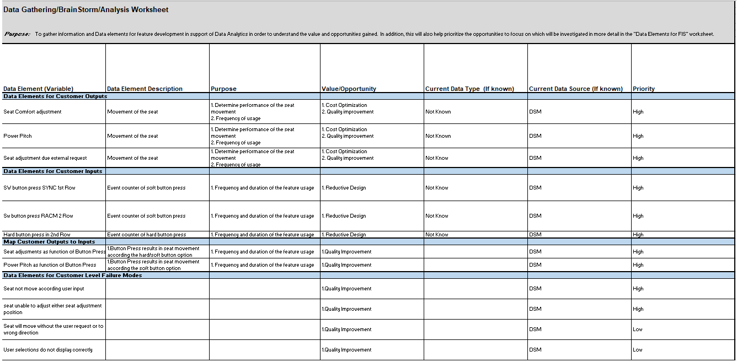

Data Elements

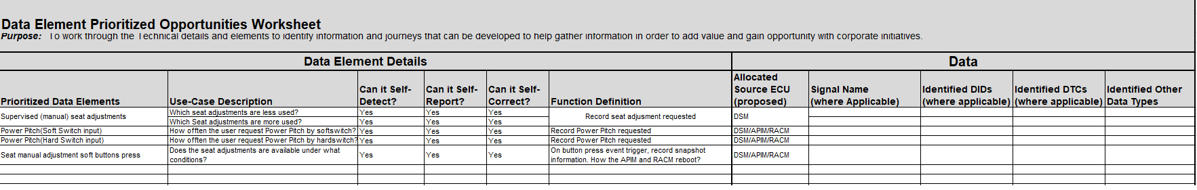

### After Sales Requirements

No After Sales Requirements specified.

### Process Requirements

No Process Requirements specified.

### Uncategorized Requirements

Rearward Move Timing for Easy Ingress/Egress

The overall ingress/egress process, from the time of the User request to return pitch/slide rearward, shall take no more than "Pitch/Slide Rearward Time" seconds.

|  |  |  |  |  |  |  |  |
| --- | --- | --- | --- | --- | --- | --- | --- |
| Requirement ID: | | | | | | | |
| **Rationale** | Provide reseating of 2nd Row Seating in a timely manner in support of vehicle driveability. | | | | | | |
| **Acceptance Criteria** | The time it takes from the user requesting reseating of the Second Row Seat to it being latched and reseated shall be <= "x" seconds. | | | | | | |
| **Notes** | This describes the time it should take to return the 2nd row seat rearward. | | | | | | |
| **Source** | Diana Aguilar | | | | | **Owner** | Diana Aguilar |
| **Source Req.** |  | | | | | **V&V Method** | Manually timing operation. |
| **Type** |  | | | **Priority** | 1 - High | **Status** | In-Progress |
| [Req. Template](http://wiki.ford.com/display/RequirementsEngineering/Requirements+Attributes) Version | | 6.0 | End of Requirement | | | | |

Forward Move Timing for Easy Ingress/Egress

The overall ingress/egress process, from the time of the User request to full pitch/slide forward, shall take no more than "Pitch/Slide Forward Time" seconds.

|  |  |  |  |  |  |  |  |
| --- | --- | --- | --- | --- | --- | --- | --- |
| Requirement ID: | | | | | | | |
| **Rationale** | Provide user access to 3rd Row Seating in a timely manner. | | | | | | |
| **Acceptance Criteria** | The time it takes from the user requesting Ingress/Egress until the Second Row Seat to be fully pitched and slid forward shall be <= "x" seconds. | | | | | | |
| **Notes** | This describes the time it should take to pitch/slide the seat forward to allow access to the 3rd row seat. | | | | | | |
| **Source** | Diana Aguilar | | | | | **Owner** | Diana Aguilar |
| **Source Req.** |  | | | | | **V&V Method** | Manually timing operation. |
| **Type** |  | | | **Priority** | 1 - High | **Status** | In-Progress |
| [Req. Template](http://wiki.ford.com/display/RequirementsEngineering/Requirements+Attributes) Version | | 6.0 | End of Requirement | | | | |

# Functional Safety

## System Behaviors for HARA

|  |  |
| --- | --- |
| **ID** | **Name** |
|  | Second Row Seats Power Pitch Forward Adjustment |
|  | Second Row Seats Calf Raise Down Comfort Adjustment |
|  | Second Row Seats Lumbar Fore Support Comfort Adjustment |
|  | SysBehavior1 |
|  | Second Row Seats Lumbar Aft Support Comfort Adjustment |
|  | Second Row Seats Backward Comfort Adjustment |
|  | Second Row Seats Recliner Forward Adjustment |
|  | Second Row Seats Calf Raise Up Comfort Adjustment |
|  | Second Row Seats Forward Comfort Adjustment |
|  | Second Row Seats Recliner Rearward Comfort Adjustment |
|  | Second Row Seats Power Pitch Backward (Initial Position) Adjustment |

Table 13: System Behaviors for HARA

## Safety Assumptions

No Safety Assumptions specified

## Safety Goals

|  |  |  |  |  |
| --- | --- | --- | --- | --- |
| ID | Goal | | | |
| **SG01** | **Goal Name** | Prevent forward rotation of seat while at speed | | |
| **Description** | Rotation of seat while driving at speed shall be prevented | | |
| **Safety Goal Concept** | Safety Goal Concept: | | |
| **ASIL** | A | **FTTI** |  |
| **Related FSR IDs** | * FSR1 * FSR2 * FSR3 * FSR4 * FSR5 * FSR6 * FSR7 * FSR8 | | |

Table 15: Functional Safety Goals

## Functional Safety Requirements

### Safety Goal: SG01 Prevent forward rotation of seat while at speed

**Name:**  Prevent forward rotation of seat while at speed

**Purpose:** Preventing seat from unlatching and moving out of position at speed and during sudden braking or accidents will prevent entanglement or contact with moving parts from occuring

**Text:** Rotation of seat while driving at speed shall be prevented

**ASIL:** A

#### Safety Goal Concept

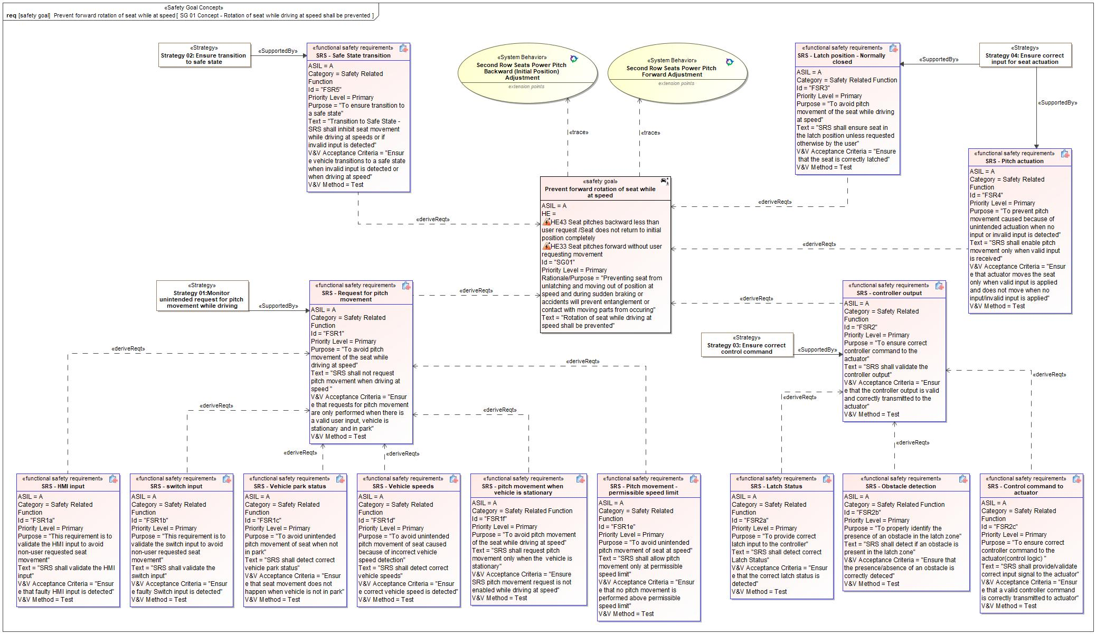

Figure 1: SG 01 Concept - Rotation of seat while driving at speed shall be prevented – Prevent forward rotation of seat while at speed

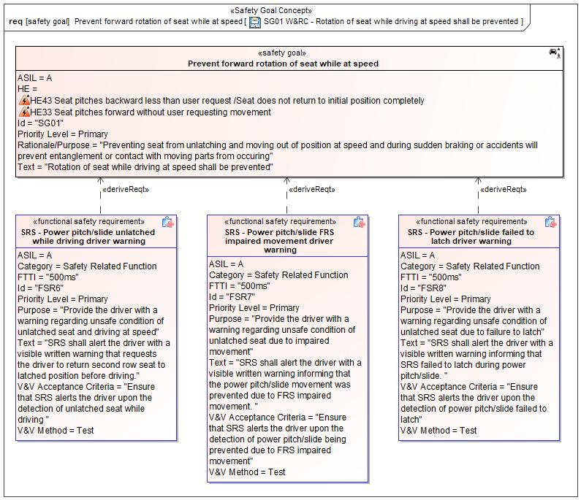

Figure 1: SG01 W&RC - Rotation of seat while driving at speed shall be prevented – Prevent forward rotation of seat while at speed

*Note: The authoritative source for the Safety Goals is document “FFSD 02 Hazard Analysis* *and Risk Assessment”. The documentation of Safety Goals in this chapter (In the Argumentation for Safety Goal achievement) is for information purposes only.*

*The authoritative source for the Functional Safety Requirements is section 2.1.x.3: of this document. The documentation of Functional Safety Requirements in the following chapter (complete or summarised) is for information purposes only.*

#### Warning and Recovery Concept

No Warning and Recovery Concept diagram specified.

#### Functional Safety Requirements without Dedicated Diagram

FSR1 SRS - Request for pitch movement

SRS shall not request pitch movement when driving at speed

Satisfied by:

* Logicals:
  + HMI Actuator
  + HMI Controller
  + HMI System
  + SRS Pitch/Slide Controller

Related to:

* Safe States:
  + Safe State -Inhibit seat movement

|  |  |  |  |  |  |  |  |
| --- | --- | --- | --- | --- | --- | --- | --- |
| Requirement ID: FSR1 | | | | | | | |
| **Purpose** | To avoid pitch movement of the seat while driving at speed | | | | | | |
| **V&V Acceptance Criteria** | Ensure that requests for pitch movement are only performed when there is a valid user input, vehicle is stationary and in park | | | | | | |
| **Notes** |  | | | | | | |
| **Source** |  | | | | | **Owner** |  |
| **Source Req.** | * 1278964334.jpg SG01  Prevent forward rotation of seat while at speed | | | | | **V&V Method** | Test |
| **Type** | N/A | | **Priority** | | N/A | **Status** | In-Progress |
| **ASIL** | A | | **Category** | | Safety Related Function | **Fault Handling Time** | N/A |
| [Req. Template](http://wiki.ford.com/display/RequirementsEngineering/Requirements+Attributes) Version | | 6.0 | | End of Requirement | | | |

FSR1a SRS - HMI input

SRS shall validate the HMI input

Satisfied by:

* Logicals:
  + HMI System
  + SRS Pitch/Slide System

Related to:

* Safe States:
  + Safe State -Inhibit seat movement

|  |  |  |  |  |  |  |  |
| --- | --- | --- | --- | --- | --- | --- | --- |
| Requirement ID: FSR1a | | | | | | | |
| **Purpose** | This requirement is to validate the HMI input to avoid non-user requested seat movement | | | | | | |
| **V&V Acceptance Criteria** | Ensure that faulty HMI input is detected | | | | | | |
| **Notes** |  | | | | | | |
| **Source** |  | | | | | **Owner** |  |
| **Source Req.** | * -454083037.jpg FSR1 SRS - Request for pitch movement * 1278964334.jpg SG01  Prevent forward rotation of seat while at speed | | | | | **V&V Method** | Test |
| **Type** | N/A | | **Priority** | | N/A | **Status** | In-Progress |
| **ASIL** | A | | **Category** | | Safety Related Function | **Fault Handling Time** | N/A |
| [Req. Template](http://wiki.ford.com/display/RequirementsEngineering/Requirements+Attributes) Version | | 6.0 | | End of Requirement | | | |

FSR1b SRS - switch input

SRS shall validate the switch input

Satisfied by:

* Logicals:
  + SRS Pitch Actuator
  + SRS Pitch/Slide System

Related to:

* Safe States:
  + Safe State -Inhibit seat movement

|  |  |  |  |  |  |  |  |
| --- | --- | --- | --- | --- | --- | --- | --- |
| Requirement ID: FSR1b | | | | | | | |
| **Purpose** | This requirement is to validate the switch input to avoid non-user requested seat movement | | | | | | |
| **V&V Acceptance Criteria** | Ensure faulty Switch input is detected | | | | | | |
| **Notes** |  | | | | | | |
| **Source** |  | | | | | **Owner** |  |
| **Source Req.** | * -454083037.jpg FSR1 SRS - Request for pitch movement * 1278964334.jpg SG01  Prevent forward rotation of seat while at speed | | | | | **V&V Method** | Test |
| **Type** | N/A | | **Priority** | | N/A | **Status** | In-Progress |
| **ASIL** | A | | **Category** | | Safety Related Function | **Fault Handling Time** | N/A |
| [Req. Template](http://wiki.ford.com/display/RequirementsEngineering/Requirements+Attributes) Version | | 6.0 | | End of Requirement | | | |

FSR1c SRS - Vehicle park status

SRS shall detect correct vehicle park status

Satisfied by:

* Logicals:
  + Vehicle Status Provider System

Related to:

* Safe States:
  + Safe State -Inhibit seat movement

|  |  |  |  |  |  |  |  |
| --- | --- | --- | --- | --- | --- | --- | --- |
| Requirement ID: FSR1c | | | | | | | |
| **Purpose** | To avoid unintended pitch movement of seat when not in park | | | | | | |
| **V&V Acceptance Criteria** | Ensure that seat movement does not happen when vehicle is not in park | | | | | | |
| **Notes** |  | | | | | | |
| **Source** |  | | | | | **Owner** |  |
| **Source Req.** | * -454083037.jpg FSR1 SRS - Request for pitch movement * 1278964334.jpg SG01  Prevent forward rotation of seat while at speed | | | | | **V&V Method** | Test |
| **Type** | N/A | | **Priority** | | N/A | **Status** | In-Progress |
| **ASIL** | A | | **Category** | | Safety Related Function | **Fault Handling Time** | N/A |
| [Req. Template](http://wiki.ford.com/display/RequirementsEngineering/Requirements+Attributes) Version | | 6.0 | | End of Requirement | | | |

FSR1d SRS - Vehicle speeds

SRS shall detect correct vehicle speeds

Satisfied by:

* Logicals:
  + Vehicle Status Provider System
  + Vehicle System

Related to:

* Safe States:
  + Safe State -Inhibit seat movement

|  |  |  |  |  |  |  |  |
| --- | --- | --- | --- | --- | --- | --- | --- |
| Requirement ID: FSR1d | | | | | | | |
| **Purpose** | To avoid unintended pitch movement of seat caused because of incorrect vehicle speed detection | | | | | | |
| **V&V Acceptance Criteria** | Ensure correct vehicle speed is detected | | | | | | |
| **Notes** |  | | | | | | |
| **Source** |  | | | | | **Owner** |  |
| **Source Req.** | * -454083037.jpg FSR1 SRS - Request for pitch movement * 1278964334.jpg SG01  Prevent forward rotation of seat while at speed | | | | | **V&V Method** | Test |
| **Type** | N/A | | **Priority** | | N/A | **Status** | In-Progress |
| **ASIL** | A | | **Category** | | Safety Related Function | **Fault Handling Time** | N/A |
| [Req. Template](http://wiki.ford.com/display/RequirementsEngineering/Requirements+Attributes) Version | | 6.0 | | End of Requirement | | | |

FSR1e SRS - Pitch movement -permissible speed limit

SRS shall allow pitch movement only at permissible speed limit

Satisfied by:

* Logicals:
  + SRS Pitch/Slide Controller
  + SRS Pitch/Slide System
  + Vehicle System

Related to:

* Safe States:
  + Safe State -Inhibit seat movement

|  |  |  |  |  |  |  |  |
| --- | --- | --- | --- | --- | --- | --- | --- |
| Requirement ID: FSR1e | | | | | | | |
| **Purpose** | To avoid unintended pitch movement of seat at speed | | | | | | |
| **V&V Acceptance Criteria** | Ensure that no pitch movement is performed above permissible speed limit | | | | | | |
| **Notes** |  | | | | | | |
| **Source** |  | | | | | **Owner** |  |
| **Source Req.** | * -454083037.jpg FSR1 SRS - Request for pitch movement * 1278964334.jpg SG01  Prevent forward rotation of seat while at speed | | | | | **V&V Method** | Test |
| **Type** | N/A | | **Priority** | | N/A | **Status** | In-Progress |
| **ASIL** | A | | **Category** | | Safety Related Function | **Fault Handling Time** | N/A |
| [Req. Template](http://wiki.ford.com/display/RequirementsEngineering/Requirements+Attributes) Version | | 6.0 | | End of Requirement | | | |

FSR1f SRS - pitch movement when vehicle is stationary

SRS shall request pitch movement only when the vehicle is stationary

Satisfied by:

* Logicals:
  + HMI Actuator
  + HMI Controller
  + HMI System
  + SRS Pitch/Slide Controller
  + SRS Pitch/Slide System

Related to:

* Safe States:
  + Safe State -Inhibit seat movement

|  |  |  |  |  |  |  |  |
| --- | --- | --- | --- | --- | --- | --- | --- |
| Requirement ID: FSR1f | | | | | | | |
| **Purpose** | To avoid pitch movement of the seat while driving at speed | | | | | | |
| **V&V Acceptance Criteria** | Ensure SRS pitch movement request is not enabled while driving at speed | | | | | | |
| **Notes** |  | | | | | | |
| **Source** |  | | | | | **Owner** |  |
| **Source Req.** | * -454083037.jpg FSR1 SRS - Request for pitch movement * 1278964334.jpg SG01  Prevent forward rotation of seat while at speed | | | | | **V&V Method** | Test |
| **Type** | N/A | | **Priority** | | N/A | **Status** | In-Progress |
| **ASIL** | A | | **Category** | | Safety Related Function | **Fault Handling Time** | N/A |
| [Req. Template](http://wiki.ford.com/display/RequirementsEngineering/Requirements+Attributes) Version | | 6.0 | | End of Requirement | | | |

FSR2 SRS - controller output

SRS shall validate the controller output

Satisfied by:

* Logicals:
  + SRS Pitch/Slide Controller
  + Vehicle Status Provider System

Related to:

* Safe States:
  + Safe State -Inhibit seat movement

|  |  |  |  |  |  |  |  |
| --- | --- | --- | --- | --- | --- | --- | --- |
| Requirement ID: FSR2 | | | | | | | |
| **Purpose** | To ensure correct controller command to the actuator | | | | | | |
| **V&V Acceptance Criteria** | Ensure that the controller output is valid and correctly transmitted to the actuator | | | | | | |
| **Notes** |  | | | | | | |
| **Source** |  | | | | | **Owner** |  |
| **Source Req.** | * 1278964334.jpg SG01  Prevent forward rotation of seat while at speed | | | | | **V&V Method** | Test |
| **Type** | N/A | | **Priority** | | N/A | **Status** | In-Progress |
| **ASIL** | A | | **Category** | | Safety Related Function | **Fault Handling Time** | N/A |
| [Req. Template](http://wiki.ford.com/display/RequirementsEngineering/Requirements+Attributes) Version | | 6.0 | | End of Requirement | | | |

FSR2a SRS - Latch Status

SRS shall detect correct Latch Status

Satisfied by:

* Logicals:
  + SRS Latch Sensor
  + SRS Pitch/Slide Controller

Related to:

* Safe States:
  + Safe State -Inhibit seat movement

|  |  |  |  |  |  |  |  |
| --- | --- | --- | --- | --- | --- | --- | --- |
| Requirement ID: FSR2a | | | | | | | |
| **Purpose** | To provide correct latch input to the controller | | | | | | |
| **V&V Acceptance Criteria** | Ensure that the correct latch status is detected | | | | | | |
| **Notes** |  | | | | | | |
| **Source** |  | | | | | **Owner** |  |
| **Source Req.** | * -454083037.jpg FSR2 SRS - controller output * 1278964334.jpg SG01  Prevent forward rotation of seat while at speed | | | | | **V&V Method** | Test |
| **Type** | N/A | | **Priority** | | N/A | **Status** | In-Progress |
| **ASIL** | A | | **Category** | | Safety Related Function | **Fault Handling Time** | N/A |
| [Req. Template](http://wiki.ford.com/display/RequirementsEngineering/Requirements+Attributes) Version | | 6.0 | | End of Requirement | | | |

FSR2b SRS - Obstacle detection

SRS shall detect if an obstacle is present in the latch zone

Satisfied by:

* Logicals:
  + SRS Pitch Obstacle Detection Sensor

Related to:

* Safe States:
  + Safe State -Inhibit seat movement

|  |  |  |  |  |  |  |  |
| --- | --- | --- | --- | --- | --- | --- | --- |
| Requirement ID: FSR2b | | | | | | | |
| **Purpose** | To properly identify the presence of an obstacle in the latch zone | | | | | | |
| **V&V Acceptance Criteria** | Ensure that the presence/absence of an obstacle is correctly deteced | | | | | | |
| **Notes** |  | | | | | | |
| **Source** |  | | | | | **Owner** |  |
| **Source Req.** | * -454083037.jpg FSR2 SRS - controller output * 1278964334.jpg SG01  Prevent forward rotation of seat while at speed | | | | | **V&V Method** | Test |
| **Type** | N/A | | **Priority** | | N/A | **Status** | In-Progress |
| **ASIL** | A | | **Category** | | Safety Related Function | **Fault Handling Time** | N/A |
| [Req. Template](http://wiki.ford.com/display/RequirementsEngineering/Requirements+Attributes) Version | | 6.0 | | End of Requirement | | | |

FSR2c SRS - Control command to actuator

SRS shall provide/validate correct input signal to the actuator

Satisfied by:

* Logicals:
  + SRS Pitch/Slide Controller

Related to:

* Safe States:
  + Safe State -Inhibit seat movement

|  |  |  |  |  |  |  |  |
| --- | --- | --- | --- | --- | --- | --- | --- |
| Requirement ID: FSR2c | | | | | | | |
| **Purpose** | To ensure correct controller command to the actuator(control logic) | | | | | | |
| **V&V Acceptance Criteria** | Ensure that a valid controller command is correctly transmitted to actuator | | | | | | |
| **Notes** |  | | | | | | |
| **Source** |  | | | | | **Owner** |  |
| **Source Req.** | * -454083037.jpg FSR2 SRS - controller output * 1278964334.jpg SG01  Prevent forward rotation of seat while at speed | | | | | **V&V Method** | Test |
| **Type** | N/A | | **Priority** | | N/A | **Status** | In-Progress |
| **ASIL** | A | | **Category** | | Safety Related Function | **Fault Handling Time** | N/A |
| [Req. Template](http://wiki.ford.com/display/RequirementsEngineering/Requirements+Attributes) Version | | 6.0 | | End of Requirement | | | |

FSR3 SRS - Latch position - Normally closed

SRS shall ensure seat in the latch position unless requested otherwise by the user

Satisfied by:

* Logicals:
  + SRS Latch Actuator

Related to:

* Safe States:
  + Safe State -Inhibit seat movement

|  |  |  |  |  |  |  |  |
| --- | --- | --- | --- | --- | --- | --- | --- |
| Requirement ID: FSR3 | | | | | | | |
| **Purpose** | To avoid pitch movement of the seat while driving at speed | | | | | | |
| **V&V Acceptance Criteria** | Ensure that the seat is correctly latched | | | | | | |
| **Notes** |  | | | | | | |
| **Source** |  | | | | | **Owner** |  |
| **Source Req.** | * 1278964334.jpg SG01  Prevent forward rotation of seat while at speed | | | | | **V&V Method** | Test |
| **Type** | N/A | | **Priority** | | N/A | **Status** | In-Progress |
| **ASIL** | A | | **Category** | | Safety Related Function | **Fault Handling Time** | N/A |
| [Req. Template](http://wiki.ford.com/display/RequirementsEngineering/Requirements+Attributes) Version | | 6.0 | | End of Requirement | | | |

FSR4 SRS - Pitch actuation

SRS shall enable pitch movement only when valid input is received

Satisfied by:

* Logicals:
  + SRS Pitch Actuator

Related to:

* Safe States:
  + Safe State -Inhibit seat movement

|  |  |  |  |  |  |  |  |
| --- | --- | --- | --- | --- | --- | --- | --- |
| Requirement ID: FSR4 | | | | | | | |
| **Purpose** | To prevent pitch movement caused because of unintended actuation when no input or invalid input is detected | | | | | | |
| **V&V Acceptance Criteria** | Ensure that actuator moves the seat only when valid input is applied and does not move when no input/invalid input is applied | | | | | | |
| **Notes** |  | | | | | | |
| **Source** |  | | | | | **Owner** |  |
| **Source Req.** | * 1278964334.jpg SG01  Prevent forward rotation of seat while at speed | | | | | **V&V Method** | Test |
| **Type** | N/A | | **Priority** | | N/A | **Status** | In-Progress |
| **ASIL** | A | | **Category** | | Safety Related Function | **Fault Handling Time** | N/A |
| [Req. Template](http://wiki.ford.com/display/RequirementsEngineering/Requirements+Attributes) Version | | 6.0 | | End of Requirement | | | |

FSR5 SRS - Safe State transition

Transition to Safe State - SRS shall inhibit seat movement while driving at speeds or if invalid input is detected

Satisfied by:

* Logicals:
  + SRS Pitch Actuator

Related to:

* Safe States:
  + Safe State -Inhibit seat movement

|  |  |  |  |  |  |  |  |
| --- | --- | --- | --- | --- | --- | --- | --- |
| Requirement ID: FSR5 | | | | | | | |
| **Purpose** | To ensure transition to a safe state | | | | | | |
| **V&V Acceptance Criteria** | Ensure vehicle transitions to a safe state when invalid input is detected or when driving at speed | | | | | | |
| **Notes** |  | | | | | | |
| **Source** |  | | | | | **Owner** |  |
| **Source Req.** | * 1278964334.jpg SG01  Prevent forward rotation of seat while at speed | | | | | **V&V Method** | Test |
| **Type** | N/A | | **Priority** | | N/A | **Status** | In-Progress |
| **ASIL** | A | | **Category** | | Safety Related Function | **Fault Handling Time** | N/A |
| [Req. Template](http://wiki.ford.com/display/RequirementsEngineering/Requirements+Attributes) Version | | 6.0 | | End of Requirement | | | |

FSR6 SRS - Power pitch/slide unlatched while driving driver warning

SRS shall alert the driver with a visible written warning that requests the driver to return second row seat to latched position before driving.

|  |  |  |  |  |  |  |  |
| --- | --- | --- | --- | --- | --- | --- | --- |
| Requirement ID: FSR6 | | | | | | | |
| **Purpose** | Provide the driver with a warning regarding unsafe condition of unlatched seat and driving at speed | | | | | | |
| **V&V Acceptance Criteria** | Ensure that SRS alerts the driver upon the detection of unlatched seat while driving | | | | | | |
| **Notes** |  | | | | | | |
| **Source** |  | | | | | **Owner** |  |
| **Source Req.** | * -454083037.jpg FSR5 SRS - Safe State transition * 1278964334.jpg SG01  Prevent forward rotation of seat while at speed | | | | | **V&V Method** | Test |
| **Type** | N/A | | **Priority** | | N/A | **Status** | In-Progress |
| **ASIL** | A | | **Category** | | Safety Related Function | **Fault Handling Time** | N/A |
| [Req. Template](http://wiki.ford.com/display/RequirementsEngineering/Requirements+Attributes) Version | | 6.0 | | End of Requirement | | | |

FSR7 SRS - Power pitch/slide FRS impaired movement driver warning

SRS shall alert the driver with a visible written warning informing that the power pitch/slide movement was prevented due to FRS impaired movement.

|  |  |  |  |  |  |  |  |
| --- | --- | --- | --- | --- | --- | --- | --- |
| Requirement ID: FSR7 | | | | | | | |
| **Purpose** | Provide the driver with a warning regarding unsafe condition of unlatched seat due to impaired movement | | | | | | |
| **V&V Acceptance Criteria** | Ensure that SRS alerts the driver upon the detection of power pitch/slide being prevented due to FRS impaired movement | | | | | | |
| **Notes** |  | | | | | | |
| **Source** |  | | | | | **Owner** |  |
| **Source Req.** | * 1278964334.jpg SG01  Prevent forward rotation of seat while at speed | | | | | **V&V Method** | Test |
| **Type** | N/A | | **Priority** | | N/A | **Status** | In-Progress |
| **ASIL** | A | | **Category** | | Safety Related Function | **Fault Handling Time** | N/A |
| [Req. Template](http://wiki.ford.com/display/RequirementsEngineering/Requirements+Attributes) Version | | 6.0 | | End of Requirement | | | |

FSR8 SRS - Power pitch/slide failed to latch driver warning

SRS shall alert the driver with a visible written warning informing that SRS failed to latch during power pitch/slide.

|  |  |  |  |  |  |  |  |
| --- | --- | --- | --- | --- | --- | --- | --- |
| Requirement ID: FSR8 | | | | | | | |
| **Purpose** | Provide the driver with a warning regarding unsafe condition of unlatched seat due to failure to latch | | | | | | |
| **V&V Acceptance Criteria** | Ensure that SRS alerts the driver upon the detection of power pitch/slide failed to latch | | | | | | |
| **Notes** |  | | | | | | |
| **Source** |  | | | | | **Owner** |  |
| **Source Req.** | * 1278964334.jpg SG01  Prevent forward rotation of seat while at speed | | | | | **V&V Method** | Test |
| **Type** | N/A | | **Priority** | | N/A | **Status** | In-Progress |
| **ASIL** | A | | **Category** | | Safety Related Function | **Fault Handling Time** | N/A |
| [Req. Template](http://wiki.ford.com/display/RequirementsEngineering/Requirements+Attributes) Version | | 6.0 | | End of Requirement | | | |

### Derivation of Functional Safety Requirements on Assumptions

No Functional Safety Requirements tracing to Assumptions specified.

## ASIL Decomposition of Functional Safety Requirements

No Functional Safety Requirements with ASIL Decompositions specified.

# CyberSecurity

## Security Goals

|  |  |  |
| --- | --- | --- |
| ID | Goal | |
|  | **Goal Name** |  |
| **Description** |  |
| **CAL** |  |
| **Related CSR IDs** |  |
|  | **Goal Name** |  |
| **Description** |  |
| **CAL** |  |
| **Related CSR IDs** |  |
|  | **Goal Name** |  |
| **Description** |  |
| **CAL** |  |
| **Related CSR IDs** |  |

Table 18: Cybersecurity Goals

## Cybersecurity Requirements

# Architecture

## Functional Architecture

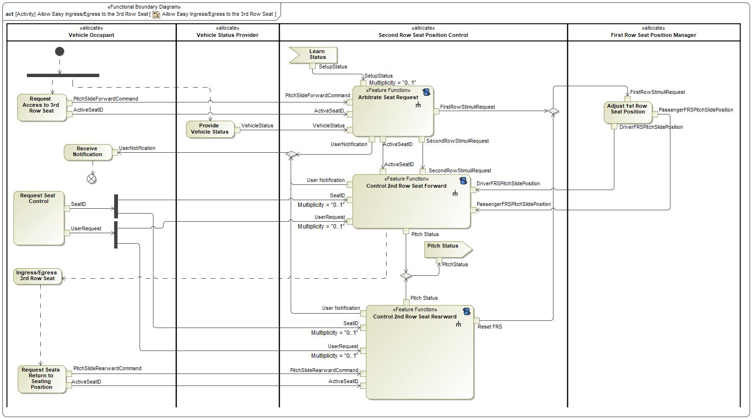

Figure 8: Allow Easy Ingress/Egress to the 3rd Row Seat

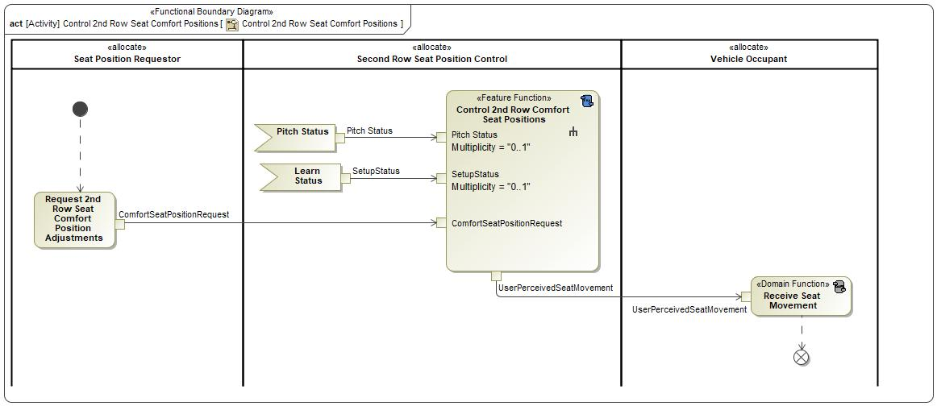

Figure 8: Control 2nd Row Seat Comfort Positions

### List of Functions

| **Function Name** | Description | Comments |
| --- | --- | --- |
| *(activity)* Request Seat Control |  |  |
| *(action)* Adjust 1st Row Seat Position  *(activity)* Adjust 1st Row Seat Position | *(action)* When the FRS is given permission to begin moving forward so that the SRS may pitch forward, it will send the SRS its position so that the SRS will know that the FRS is out of the way for the SRS to begin pitching/sliding forward. |  |
| *(action)* Arbitrate Seat Request  *(activity)* Arbitrate Seat Request | *(action)* This will check the status of the vehicle to confirm that it is able to begin the PPSEEE Pitch/Slide Process.  *(activity)* This will check the status of the vehicle to confirm that it is able to begin the PPSEEE Pitch/Slide Process. |  |
| *(action)* Control 2nd Row Seat Rearward  *(activity)* Control 2nd Row Seat Rearward | *(action)* When the SRS is requested to pitch rearward, this will control the rearward movement of the requested SRS PPSEEE Return Process.  *(activity)* When the SRS is requested to pitch rearward, this will contain the rearward movement of the requested SRS (PPSEEE Return Process). |  |
| *(action)* Ingress/Egress 3rd Row Seat  *(activity)* Ingress/Egress 3rd Row Seat | *(action)* This is the User entering/exiting the TRS. |  |
| *(action)* Provide Vehicle Status  *(activity)* Provide Vehicle Status | *(action)* This provides the status of the vehicle for which the PPSEEE Pitch/Slide Process can function. |  |
| *(action)* Receive Notification  *(activity)* Receive Notification | *(action)* User will be notified if the PPSEEE Pitch/Slide Process or the PPSEEE Return Process has been terminated for any reason or if the conditions aren't correct to begin the PPSEEE Pitch/Slide Process. |  |
| *(action)* Request Access to 3rd Row Seat  *(activity)* Request Access to 3rd Row Seat | *(action)* This represents the User selecting the SRS to be pitched forward for easy ingress/egress to the TRS via the PPSEEE Pitch/Slide Process. |  |
| *(action)* Request Seats Return to Seating Position  *(activity)* Request Seats Return to Seating Position | *(action)* This represents the User selecting the SRS to be pitched rearward in order to reseat the seat via the PPSEEE Return Process. |  |
| *(action)* ​Control 2nd Row Seat Forward  *(activity)* ​Control 2nd Row Seat Forward | *(action)* When the SRS is requested to pitch forward and the conditions are met, this will control the forward movement of the requested SRS (PPSEEE Pitch/Slide Process).  *(activity)* When the SRS is requested to pitch forward and the conditions are met, this will contain the forward movement of the requested SRS (PPSEEE Pitch/Slide Process). |  |

Table 17: List of Functions on Allow Easy Ingress/Egress to the 3rd Row Seat

| **Function Name** | Description | Comments |
| --- | --- | --- |
| *(activity)* Receive Seat Movement |  |  |
| *(action)* Control 2nd Row Comfort Seat Positions  *(activity)* Control 2nd Row Comfort Seat Positions | *(activity)* This is to provide the User to be able to adjust the comfort seats of the requested SRS. |  |
| *(action)* Request 2nd Row Seat Comfort Position Adjustments  *(activity)* Request 2nd Row Seat Comfort Position Adjustments | *(action)* This is the request from the User to move the comfort settings of the seat. |  |

Table 17: List of Functions on Control 2nd Row Seat Comfort Positions

## Logical Architecture

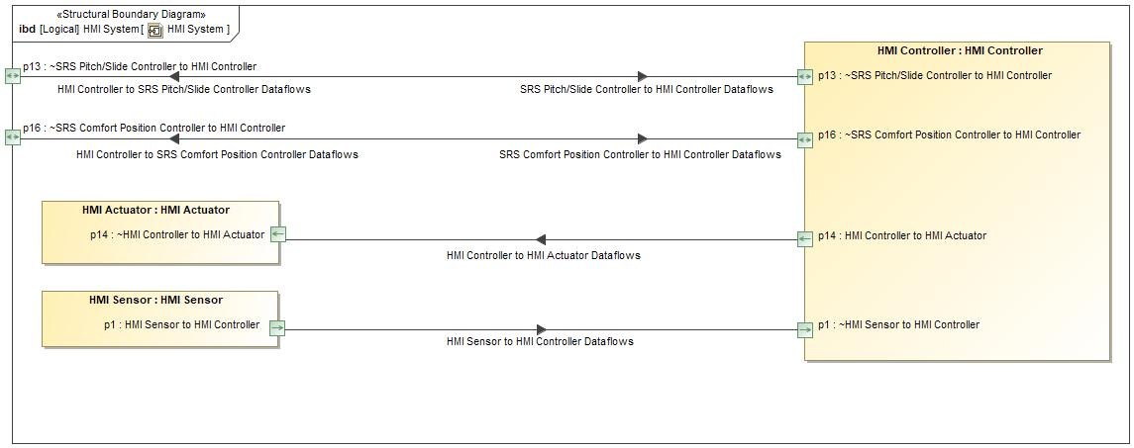

Figure 9: HMI System

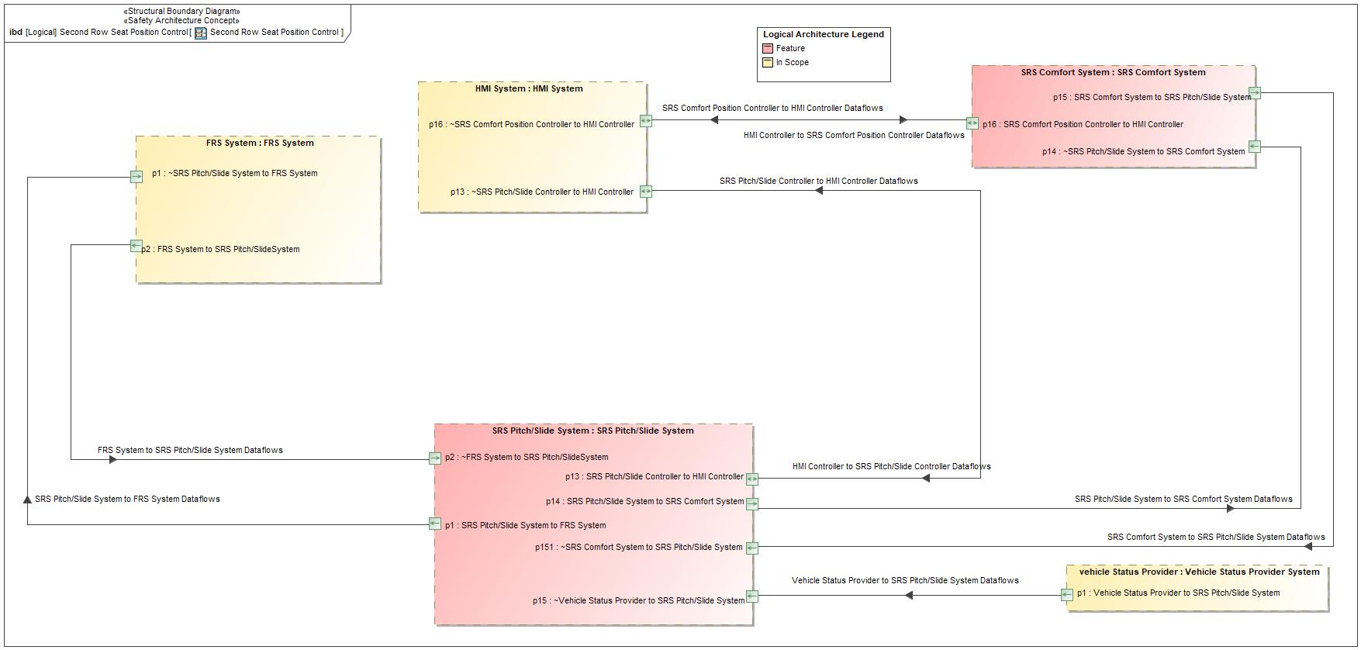

Figure 9: Second Row Seat Position Control

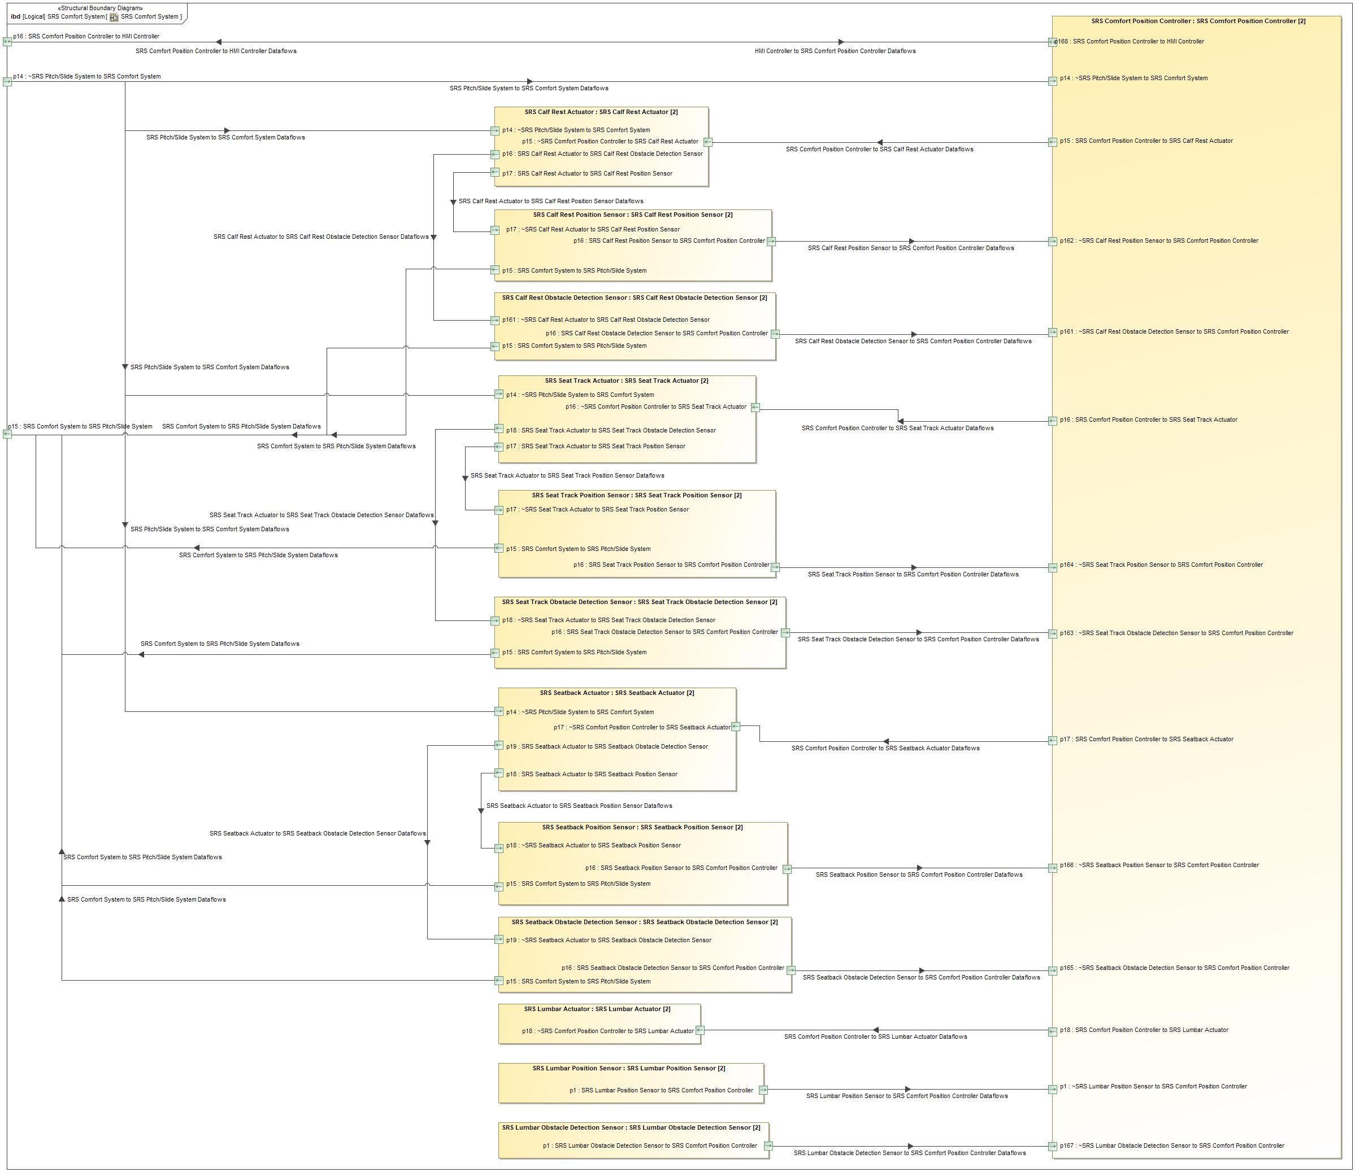

Figure 9: SRS Comfort System

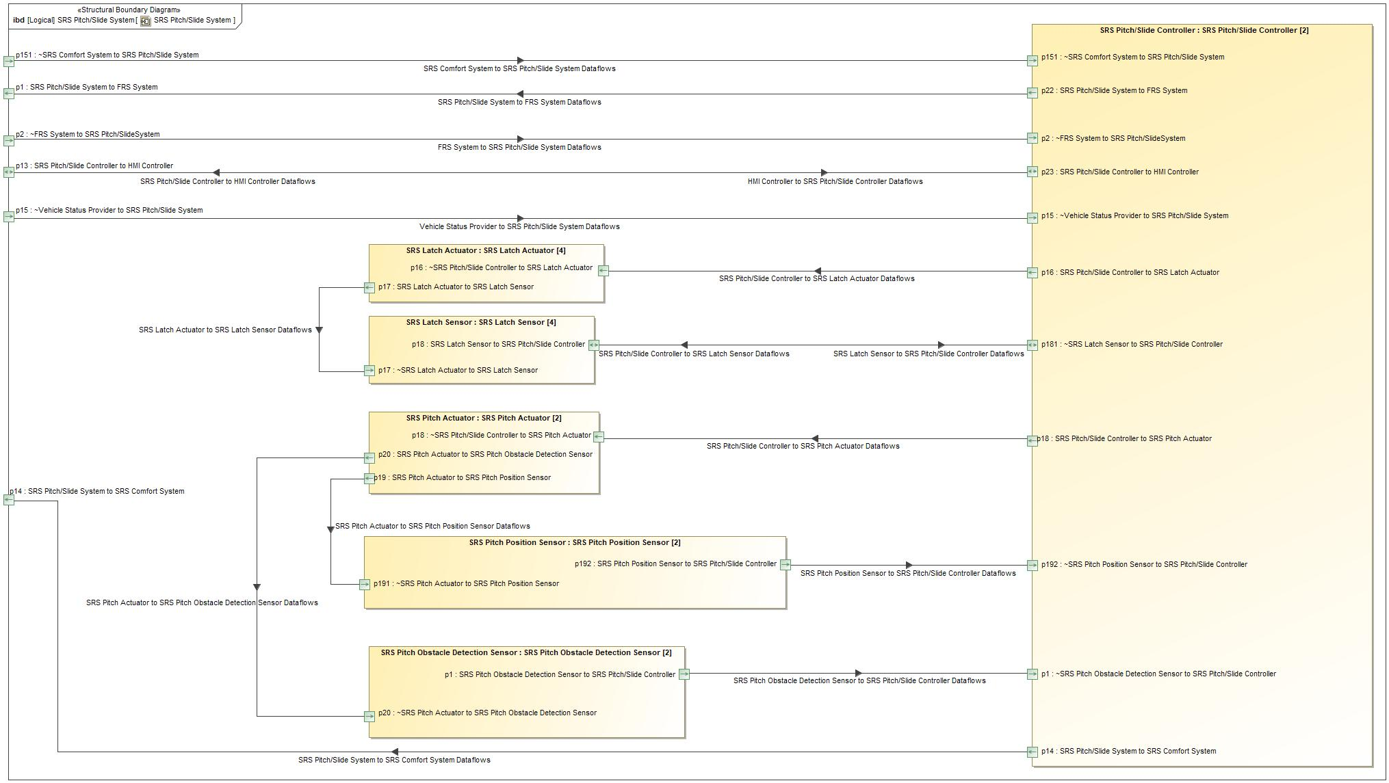

Figure 9: SRS Pitch/Slide System

### Logical Elements

|  |  |  |  |
| --- | --- | --- | --- |
| **Element Name** | **Description** | **Allocated Functions** | **Comments** |
| FRS System | This represents the FRS System. |  |  |
| HMI Actuator | The "HMI Actuator" represents the displaying of the User notification. |  |  |
| HMI Controller | The "HMI Controller" represents the controlling of the user notifications. |  |  |
| HMI Sensor |  |  |  |
| HMI System | This represents the HMI System. |  |  |
| SRS Calf Rest Actuator | This will provide the actuation of the calf rest comfort setting. |  |  |
| SRS Calf Rest Obstacle Detection Sensor | This will provide the sensing of obstacle detection of the SRS Calf Rest. |  |  |
| SRS Calf Rest Position Sensor | This will provide the position of the SRS Calf Rest. |  |  |
| SRS Comfort Position Controller | This will control the functionality of the seat comfort sensors and actuators. |  |  |
| SRS Comfort System | This represents the SRS Comfort System. |  |  |
| SRS Latch Actuator | This will provide the actuation of the SRS Latches during the PPSEEE Pitch/Slide Process and PPSEEE Return Process. |  |  |
| SRS Latch Sensor | This will provide the position of the SRS Latches during the PPSEEE Pitch/Slide Process and PPSEEE Return Process. |  |  |
| SRS Lumbar Actuator | This will provide the actuation of the lumbar comfort setting. |  |  |
| SRS Lumbar Obstacle Detection Sensor | This will provide the sensing of the obstacle detection of the SRS Lumbar. |  |  |
| SRS Lumbar Position Sensor | This will provide the position of the SRS Lumbar. |  |  |
| SRS Pitch Actuator | This will provide the actuation of the SRS Pitch during the PPSEEE Pitch/Slide Process and PPSEEE Return Process. |  |  |
| SRS Pitch Obstacle Detection Sensor | This will provide the sensing of obstacle detection of the SRS Pitch. |  |  |
| SRS Pitch Position Sensor | This will provide the position of the SRS Pitch. |  |  |
| SRS Pitch/Slide Controller | This will control the functionality of the SRS PPSEEE Pitch/Slide Process and PPSEEE Return Process. |  |  |
| SRS Pitch/Slide System | This represents the SRS Pitch/Slide System. |  |  |
| SRS Seat Track Actuator | This will provide the actuation of the fore/aft seat comfort setting. |  |  |
| SRS Seat Track Obstacle Detection Sensor | This will provide the sensing of obstacle detection of the SRS Seat Track. |  |  |
| SRS Seat Track Position Sensor | This will provide the position of the SRS Seat in relation to the Fore/Aft position. |  |  |
| SRS Seatback Actuator | This will provide the actuation of the incline/recline seatback comfort setting. |  |  |
| SRS Seatback Obstacle Detection Sensor | This will provide the sensing of obstacle detection of the SRS seatback. |  |  |
| SRS Seatback Position Sensor | This will provide the position of the SRS Seatback. |  |  |
| Vehicle Status Provider System | This represents the Vehicle Status Provider System. |  |  |

Table 19: Logical Elements

### Logical Interfaces

|  |  |  |  |
| --- | --- | --- | --- |
| **Interface** | **Direction** | **Description** | **Value Range** |
| HMI Controller to HMI Actuator Dataflows | p14 (HMI Controller) To p14 (HMI Actuator) |  | as HMI_Messages:   * OBSTACLE_DETECTED_MESSAGE * INVALID_VEHICLE_STATUS_MESSAGE * USER_TERMINATED_PROCESS_MESSAGE * INVALID_LEARN_STATUS_MESSAGE * FAILED_TO_LATCH_MESSAGE * FAILED_TO_UNLATCH_MESSAGE * FULLY_PITCHED_MESSAGE * FULLY_SEATED_MESSAGE   as LearningStatus: |
| HMI Controller to SRS Comfort Position Controller Dataflows | p16 (HMI Controller) To p16 (HMI System) |  | as SetupStatus:   * LEARNED * NOT_LEARNED   as ComfortSettings:  as SeatID:   * DRIVER_SIDE * PASSENGER_SIDE |
| HMI Controller to SRS Pitch/Slide Controller Dataflows | p13 (HMI Controller) To p13 (HMI System) |  | as SetupStatus:   * LEARNED * NOT_LEARNED |
| HMI Sensor to HMI Controller Dataflows | p1 (HMI Sensor) To p1 (HMI Controller) |  | as ComfortSettings:  as SeatID:   * DRIVER_SIDE * PASSENGER_SIDE |
| SRS Comfort Position Controller to HMI Controller Dataflows | p16 (HMI System) To p16 (HMI Controller) |  | as CalfRestLearningStatus:   * NOT_LEARNED * INVALID_RANGE * LEARNED   as SeatTrackLearningStatus:   * NOT_LEARNED * INVALID_RANGE * LEARNED   as SeatbackLearningStatus:   * NOT_LEARNED * INVALID_RANGE * LEARNED   as LumbarLearningStatus:   * NOT_LEARNED * INVALID_RANGE * LEARNED |
| SRS Pitch/Slide Controller to HMI Controller Dataflows | p13 (HMI System) To p13 (HMI Controller) |  | as PitchLearningStatus:   * NOT_LEARNED * INVALID_RANGE * LEARNED   as HMI_Feedback:   * OBSTACLE_DETECTED * INVALID_VEHICLE_STATUS * USER_TERMINATED_PROCESS * INVALID_LEARN_STATUS * FAILED_TO_LATCH * FAILED_TO_UNLATCH * FULLY_PITCHED * FULLY_SEATED |

Table 19: Feature Interactions on HMI System

|  |  |  |  |
| --- | --- | --- | --- |
| **Interface** | **Direction** | **Description** | **Value Range** |
| FRS System to SRS Pitch/Slide System Dataflows | p2 (FRS System) To p2 (SRS Pitch/Slide System) |  | as DriverFRSPitchSlidePosition:   * CLEAR_TO_MOVE * NOT_CLEAR_TO_MOVE |
| HMI Controller to SRS Comfort Position Controller Dataflows | p16 (HMI System) To p16 (SRS Comfort System) |  | as SetupStatus:   * LEARNED * NOT_LEARNED   as ComfortSettings:  as SeatID:   * DRIVER_SIDE * PASSENGER_SIDE |
| HMI Controller to SRS Pitch/Slide Controller Dataflows | p13 (HMI System) To p13 (SRS Pitch/Slide System) |  | as SetupStatus:   * LEARNED * NOT_LEARNED |
| SRS Comfort Position Controller to HMI Controller Dataflows | p16 (SRS Comfort System) To p16 (HMI System) |  | as CalfRestLearningStatus:   * NOT_LEARNED * INVALID_RANGE * LEARNED   as SeatTrackLearningStatus:   * NOT_LEARNED * INVALID_RANGE * LEARNED   as SeatbackLearningStatus:   * NOT_LEARNED * INVALID_RANGE * LEARNED   as LumbarLearningStatus:   * NOT_LEARNED * INVALID_RANGE * LEARNED |
| SRS Comfort System to SRS Pitch/Slide System Dataflows | p15 (SRS Comfort System) To p151 (SRS Pitch/Slide System) |  | as SeatbackObstacleStatus:   * OBSTACLE_DETECTED * OBSTACLE_NOT_DETECTED   as CalfRestObstacleStatus:   * OBSTACLE_DETECTED * OBSTACLE_NOT_DETECTED * UNKNOWN   as SeatTrackObstacleStatus:   * OBSTACLE_DETECTED * OBSTACLE_NOT_DETECTED   as CurrentPositionCalfRest:  as CurrentPositionSeatback:  as CurrentPositionSeatTrack: |
| SRS Pitch/Slide Controller to HMI Controller Dataflows | p13 (SRS Pitch/Slide System) To p13 (HMI System) |  | as PitchLearningStatus:   * NOT_LEARNED * INVALID_RANGE * LEARNED   as HMI_Feedback:   * OBSTACLE_DETECTED * INVALID_VEHICLE_STATUS * USER_TERMINATED_PROCESS * INVALID_LEARN_STATUS * FAILED_TO_LATCH * FAILED_TO_UNLATCH * FULLY_PITCHED * FULLY_SEATED |
| SRS Pitch/Slide System to FRS System Dataflows | p1 (SRS Pitch/Slide System) To p1 (FRS System) |  | as FirstRowSeatRequest:   * MOVE_DRIVER_FORWARD * DO_NOT_MOVE * MOVE_DRIVER_REARWARD * RESET_DRIVER * MOVE_PASSENGER_FORWARD * MOVE_PASSENGER_REARWARD * RESET_PASSENGER |
| SRS Pitch/Slide System to HMI System Dataflows | p13 (SRS Pitch/Slide System) To p13 (HMI System) |  | as HMI_Feedback:   * OBSTACLE_DETECTED * INVALID_VEHICLE_STATUS * USER_TERMINATED_PROCESS * INVALID_LEARN_STATUS * FAILED_TO_LATCH * FAILED_TO_UNLATCH * FULLY_PITCHED * FULLY_SEATED   as PitchLearningStatus:   * NOT_LEARNED * INVALID_RANGE * LEARNED |
| SRS Pitch/Slide System to SRS Comfort System Dataflows | p14 (SRS Pitch/Slide System) To p14 (SRS Comfort System) |  | as PitchStatus:   * ACTIVE * INACTIVE   as SRS_SeatbackEnabledRequest:   * FORWARD * NULL * REARWARD   as SRS_CalfEnabledRequest:   * STOW * NULL * RESET   as SRS_SeatTrackEnabledRequest:   * ACTUATE_FORWARD * NULL * ACTUATE_REARWARD |
| Vehicle Status Provider to SRS Pitch/Slide System Dataflows | p1 (Vehicle Status Provider System) To p15 (SRS Pitch/Slide System) |  | as VehicleStatus: |

Table 19: Feature Interactions on Second Row Seat Position Control

|  |  |  |  |
| --- | --- | --- | --- |
| **Interface** | **Direction** | **Description** | **Value Range** |
| HMI Controller to SRS Comfort Position Controller Dataflows | p16 (SRS Comfort System) To p168 (SRS Comfort Position Controller) |  | as SetupStatus:   * LEARNED * NOT_LEARNED   as ComfortSettings:  as SeatID:   * DRIVER_SIDE * PASSENGER_SIDE |
| SRS Calf Rest Actuator to SRS Calf Rest Obstacle Detection Sensor Dataflows | p16 (SRS Calf Rest Actuator) To p161 (SRS Calf Rest Obstacle Detection Sensor) |  | as MeasuredActuationSignal: |
| SRS Calf Rest Actuator to SRS Calf Rest Position Sensor Dataflows | p17 (SRS Calf Rest Actuator) To p17 (SRS Calf Rest Position Sensor) |  | as MeasuredActuationSignal: |
| SRS Calf Rest Obstacle Detection Sensor to SRS Comfort Position Controller Dataflows | p16 (SRS Calf Rest Obstacle Detection Sensor) To p161 (SRS Comfort Position Controller) |  | as CalfRestObstacleStatus:   * OBSTACLE_DETECTED * OBSTACLE_NOT_DETECTED * UNKNOWN |
| SRS Calf Rest Position Sensor to SRS Comfort Position Controller Dataflows | p16 (SRS Calf Rest Position Sensor) To p162 (SRS Comfort Position Controller) |  | as CurrentPositionCalfRest: |
| SRS Comfort Position Controller to HMI Controller Dataflows | p168 (SRS Comfort Position Controller) To p16 (SRS Comfort System) |  | as CalfRestLearningStatus:   * NOT_LEARNED * INVALID_RANGE * LEARNED   as SeatTrackLearningStatus:   * NOT_LEARNED * INVALID_RANGE * LEARNED   as SeatbackLearningStatus:   * NOT_LEARNED * INVALID_RANGE * LEARNED   as LumbarLearningStatus:   * NOT_LEARNED * INVALID_RANGE * LEARNED |
| SRS Comfort Position Controller to SRS Calf Rest Actuator Dataflows | p15 (SRS Comfort Position Controller) To p15 (SRS Calf Rest Actuator) |  | as CalfAdjustment:   * CALF_IN * CALF_OUT * NULL |
| SRS Comfort Position Controller to SRS Lumbar Actuator Dataflows | p18 (SRS Comfort Position Controller) To p18 (SRS Lumbar Actuator) |  | as LumbarAdjustment:   * LUMBAR_MORE_SUPPORT * LUMBAR_LESS_SUPPORT * NULL |
| SRS Comfort Position Controller to SRS Seat Track Actuator Dataflows | p16 (SRS Comfort Position Controller) To p16 (SRS Seat Track Actuator) |  | as SeatTrackAdjustment:   * SLIDE_SEAT_FORWARD * SLIDE_SEAT_REARWARD * NULL |
| SRS Comfort Position Controller to SRS Seatback Actuator Dataflows | p17 (SRS Comfort Position Controller) To p17 (SRS Seatback Actuator) |  | as SeatbackAdjustment:   * RECLINE_FORWARD * RECLINE_REARWARD * NULL |
| SRS Comfort System to SRS Pitch/Slide System Dataflows | p15 (SRS Calf Rest Obstacle Detection Sensor) To p15 (SRS Comfort System) |  | as SeatbackObstacleStatus:   * OBSTACLE_DETECTED * OBSTACLE_NOT_DETECTED   as CalfRestObstacleStatus:   * OBSTACLE_DETECTED * OBSTACLE_NOT_DETECTED * UNKNOWN   as SeatTrackObstacleStatus:   * OBSTACLE_DETECTED * OBSTACLE_NOT_DETECTED   as CurrentPositionCalfRest:  as CurrentPositionSeatback:  as CurrentPositionSeatTrack: |
| p15 (SRS Calf Rest Position Sensor) To p15 (SRS Comfort System) |  | as SeatbackObstacleStatus:   * OBSTACLE_DETECTED * OBSTACLE_NOT_DETECTED   as CalfRestObstacleStatus:   * OBSTACLE_DETECTED * OBSTACLE_NOT_DETECTED * UNKNOWN   as SeatTrackObstacleStatus:   * OBSTACLE_DETECTED * OBSTACLE_NOT_DETECTED   as CurrentPositionCalfRest:  as CurrentPositionSeatback:  as CurrentPositionSeatTrack: |
| p15 (SRS Seat Track Obstacle Detection Sensor) To p15 (SRS Comfort System) |  | as SeatbackObstacleStatus:   * OBSTACLE_DETECTED * OBSTACLE_NOT_DETECTED   as CalfRestObstacleStatus:   * OBSTACLE_DETECTED * OBSTACLE_NOT_DETECTED * UNKNOWN   as SeatTrackObstacleStatus:   * OBSTACLE_DETECTED * OBSTACLE_NOT_DETECTED   as CurrentPositionCalfRest:  as CurrentPositionSeatback:  as CurrentPositionSeatTrack: |
| p15 (SRS Seat Track Position Sensor) To p15 (SRS Comfort System) |  | as SeatbackObstacleStatus:   * OBSTACLE_DETECTED * OBSTACLE_NOT_DETECTED   as CalfRestObstacleStatus:   * OBSTACLE_DETECTED * OBSTACLE_NOT_DETECTED * UNKNOWN   as SeatTrackObstacleStatus:   * OBSTACLE_DETECTED * OBSTACLE_NOT_DETECTED   as CurrentPositionCalfRest:  as CurrentPositionSeatback:  as CurrentPositionSeatTrack: |
| p15 (SRS Seatback Obstacle Detection Sensor) To p15 (SRS Comfort System) |  | as SeatbackObstacleStatus:   * OBSTACLE_DETECTED * OBSTACLE_NOT_DETECTED   as CalfRestObstacleStatus:   * OBSTACLE_DETECTED * OBSTACLE_NOT_DETECTED * UNKNOWN   as SeatTrackObstacleStatus:   * OBSTACLE_DETECTED * OBSTACLE_NOT_DETECTED   as CurrentPositionCalfRest:  as CurrentPositionSeatback:  as CurrentPositionSeatTrack: |
| p15 (SRS Seatback Position Sensor) To p15 (SRS Comfort System) |  | as SeatbackObstacleStatus:   * OBSTACLE_DETECTED * OBSTACLE_NOT_DETECTED   as CalfRestObstacleStatus:   * OBSTACLE_DETECTED * OBSTACLE_NOT_DETECTED * UNKNOWN   as SeatTrackObstacleStatus:   * OBSTACLE_DETECTED * OBSTACLE_NOT_DETECTED   as CurrentPositionCalfRest:  as CurrentPositionSeatback:  as CurrentPositionSeatTrack: |
| SRS Lumbar Obstacle Detection Sensor to SRS Comfort Position Controller Dataflows | p1 (SRS Lumbar Obstacle Detection Sensor) To p167 (SRS Comfort Position Controller) |  | as LumbarObstacleStatus:   * OBSTACLE_DETECTED * OBSTACLE_NOT_DETECTED * UNKNOWN |
| SRS Lumbar Position Sensor to SRS Comfort Position Controller Dataflows | p1 (SRS Lumbar Position Sensor) To p1 (SRS Comfort Position Controller) |  | as CurrentPositionLumbar: |
| SRS Pitch/Slide System to SRS Comfort System Dataflows | p14 (SRS Comfort System) To p14 (SRS Calf Rest Actuator) |  | as PitchStatus:   * ACTIVE * INACTIVE   as SRS_SeatbackEnabledRequest:   * FORWARD * NULL * REARWARD   as SRS_CalfEnabledRequest:   * STOW * NULL * RESET   as SRS_SeatTrackEnabledRequest:   * ACTUATE_FORWARD * NULL * ACTUATE_REARWARD |
| p14 (SRS Comfort System) To p14 (SRS Comfort Position Controller) |  | as PitchStatus:   * ACTIVE * INACTIVE   as SRS_SeatbackEnabledRequest:   * FORWARD * NULL * REARWARD   as SRS_CalfEnabledRequest:   * STOW * NULL * RESET   as SRS_SeatTrackEnabledRequest:   * ACTUATE_FORWARD * NULL * ACTUATE_REARWARD |
| p14 (SRS Comfort System) To p14 (SRS Seat Track Actuator) |  | as PitchStatus:   * ACTIVE * INACTIVE   as SRS_SeatbackEnabledRequest:   * FORWARD * NULL * REARWARD   as SRS_CalfEnabledRequest:   * STOW * NULL * RESET   as SRS_SeatTrackEnabledRequest:   * ACTUATE_FORWARD * NULL * ACTUATE_REARWARD |
| p14 (SRS Comfort System) To p14 (SRS Seatback Actuator) |  | as PitchStatus:   * ACTIVE * INACTIVE   as SRS_SeatbackEnabledRequest:   * FORWARD * NULL * REARWARD   as SRS_CalfEnabledRequest:   * STOW * NULL * RESET   as SRS_SeatTrackEnabledRequest:   * ACTUATE_FORWARD * NULL * ACTUATE_REARWARD |
| SRS Seat Track Actuator to SRS Seat Track Obstacle Detection Sensor Dataflows | p18 (SRS Seat Track Actuator) To p18 (SRS Seat Track Obstacle Detection Sensor) |  | as MeasuredActuationSignal: |
| SRS Seat Track Actuator to SRS Seat Track Position Sensor Dataflows | p17 (SRS Seat Track Actuator) To p17 (SRS Seat Track Position Sensor) |  | as MeasuredActuationSignal: |
| SRS Seat Track Obstacle Detection Sensor to SRS Comfort Position Controller Dataflows | p16 (SRS Seat Track Obstacle Detection Sensor) To p163 (SRS Comfort Position Controller) |  | as SeatTrackObstacleStatus:   * OBSTACLE_DETECTED * OBSTACLE_NOT_DETECTED |
| SRS Seat Track Position Sensor to SRS Comfort Position Controller Dataflows | p16 (SRS Seat Track Position Sensor) To p164 (SRS Comfort Position Controller) |  | as CurrentPositionSeatTrack: |
| SRS Seatback Actuator to SRS Seatback Obstacle Detection Sensor Dataflows | p19 (SRS Seatback Actuator) To p19 (SRS Seatback Obstacle Detection Sensor) |  | as MeasuredActuationSignal: |
| SRS Seatback Actuator to SRS Seatback Position Sensor Dataflows | p18 (SRS Seatback Actuator) To p18 (SRS Seatback Position Sensor) |  | as MeasuredActuationSignal: |
| SRS Seatback Obstacle Detection Sensor to SRS Comfort Position Controller Dataflows | p16 (SRS Seatback Obstacle Detection Sensor) To p165 (SRS Comfort Position Controller) |  | as SeatbackObstacleStatus:   * OBSTACLE_DETECTED * OBSTACLE_NOT_DETECTED |
| SRS Seatback Position Sensor to SRS Comfort Position Controller Dataflows | p16 (SRS Seatback Position Sensor) To p166 (SRS Comfort Position Controller) |  | as CurrentPositionSeatback: |

Table 19: Feature Interactions on SRS Comfort System

|  |  |  |  |
| --- | --- | --- | --- |
| **Interface** | **Direction** | **Description** | **Value Range** |
| FRS System to SRS Pitch/Slide System Dataflows | p2 (SRS Pitch/Slide System) To p2 (SRS Pitch/Slide Controller) |  | as DriverFRSPitchSlidePosition:   * CLEAR_TO_MOVE * NOT_CLEAR_TO_MOVE |
| HMI Controller to SRS Pitch/Slide Controller Dataflows | p13 (SRS Pitch/Slide System) To p23 (SRS Pitch/Slide Controller) |  | as SetupStatus:   * LEARNED * NOT_LEARNED |
| SRS Comfort System to SRS Pitch/Slide System Dataflows | p151 (SRS Pitch/Slide System) To p151 (SRS Pitch/Slide Controller) |  | as SeatbackObstacleStatus:   * OBSTACLE_DETECTED * OBSTACLE_NOT_DETECTED   as CalfRestObstacleStatus:   * OBSTACLE_DETECTED * OBSTACLE_NOT_DETECTED * UNKNOWN   as SeatTrackObstacleStatus:   * OBSTACLE_DETECTED * OBSTACLE_NOT_DETECTED   as CurrentPositionCalfRest:  as CurrentPositionSeatback:  as CurrentPositionSeatTrack: |
| SRS Latch Actuator to SRS Latch Sensor Dataflows | p17 (SRS Latch Actuator) To p17 (SRS Latch Sensor) |  | as MeasuredActuationSignal: |
| SRS Latch Sensor to SRS Pitch/Slide Controller Dataflows | p18 (SRS Latch Sensor) To p181 (SRS Pitch/Slide Controller) |  | as SRS_LatchStatus:   * LATCHED * UNLATCHED |
| SRS Pitch Actuator to SRS Pitch Obstacle Detection Sensor Dataflows | p20 (SRS Pitch Actuator) To p20 (SRS Pitch Obstacle Detection Sensor) |  | as MeasuredActuationSignal: |
| SRS Pitch Actuator to SRS Pitch Position Sensor Dataflows | p19 (SRS Pitch Actuator) To p191 (SRS Pitch Position Sensor) |  | as MeasuredActuationSignal: |
| SRS Pitch Obstacle Detection Sensor to SRS Pitch/Slide Controller Dataflows | p1 (SRS Pitch Obstacle Detection Sensor) To p1 (SRS Pitch/Slide Controller) |  | as PitchObstacleStatus:   * OBSTACLE_DETECTED * OBSTACLE_NOT_DETECTED |
| SRS Pitch Position Sensor to SRS Pitch/Slide Controller Dataflows | p192 (SRS Pitch Position Sensor) To p192 (SRS Pitch/Slide Controller) |  | as CurrentPositionPitch: |
| SRS Pitch/Slide Controller to HMI Controller Dataflows | p23 (SRS Pitch/Slide Controller) To p13 (SRS Pitch/Slide System) |  | as PitchLearningStatus:   * NOT_LEARNED * INVALID_RANGE * LEARNED   as HMI_Feedback:   * OBSTACLE_DETECTED * INVALID_VEHICLE_STATUS * USER_TERMINATED_PROCESS * INVALID_LEARN_STATUS * FAILED_TO_LATCH * FAILED_TO_UNLATCH * FULLY_PITCHED * FULLY_SEATED |
| SRS Pitch/Slide Controller to SRS Latch Actuator Dataflows | p16 (SRS Pitch/Slide Controller) To p16 (SRS Latch Actuator) |  | as UnlatchCommand:   * UNLATCH * NULL |
| SRS Pitch/Slide Controller to SRS Latch Sensor Dataflows | p181 (SRS Pitch/Slide Controller) To p18 (SRS Latch Sensor) |  | as UnlatchCommand:   * UNLATCH * NULL |
| SRS Pitch/Slide Controller to SRS Pitch Actuator Dataflows | p18 (SRS Pitch/Slide Controller) To p18 (SRS Pitch Actuator) |  | as SRS_PitchEnabledRequest:   * ACTUATE_FORWARD * NULL * ACTUATE_REARWARD   as ActuatePitchSlide:   * ACTUATE_FORWARD * NO_ACTION * ACTUATE_REARWARD |
| SRS Pitch/Slide System to FRS System Dataflows | p22 (SRS Pitch/Slide Controller) To p1 (SRS Pitch/Slide System) |  | as FirstRowSeatRequest:   * MOVE_DRIVER_FORWARD * DO_NOT_MOVE * MOVE_DRIVER_REARWARD * RESET_DRIVER * MOVE_PASSENGER_FORWARD * MOVE_PASSENGER_REARWARD * RESET_PASSENGER |
| SRS Pitch/Slide System to HMI System Dataflows | p23 (SRS Pitch/Slide Controller) To p13 (SRS Pitch/Slide System) |  | as HMI_Feedback:   * OBSTACLE_DETECTED * INVALID_VEHICLE_STATUS * USER_TERMINATED_PROCESS * INVALID_LEARN_STATUS * FAILED_TO_LATCH * FAILED_TO_UNLATCH * FULLY_PITCHED * FULLY_SEATED   as PitchLearningStatus:   * NOT_LEARNED * INVALID_RANGE * LEARNED |
| SRS Pitch/Slide System to SRS Comfort System Dataflows | p14 (SRS Pitch/Slide Controller) To p14 (SRS Pitch/Slide System) |  | as PitchStatus:   * ACTIVE * INACTIVE   as SRS_SeatbackEnabledRequest:   * FORWARD * NULL * REARWARD   as SRS_CalfEnabledRequest:   * STOW * NULL * RESET   as SRS_SeatTrackEnabledRequest:   * ACTUATE_FORWARD * NULL * ACTUATE_REARWARD |
| Vehicle Status Provider to SRS Pitch/Slide System Dataflows | p15 (SRS Pitch/Slide System) To p15 (SRS Pitch/Slide Controller) |  | as VehicleStatus: |

Table 19: Feature Interactions on SRS Pitch/Slide System

# Open Concerns

| ID | Concern Description | e-Tracker / Reference | Responsible | Status | Solution |
| --- | --- | --- | --- | --- | --- |
| 1 |  |  |  |  |  |

Table 20: Open Concerns *(Not supported by MagicDraw report generation)*

# Revision History

No Revision History found.

## Template Revisions

|  |  |  |  |  |
| --- | --- | --- | --- | --- |
| Version | Rev. | Date | Description | Responsible |
| *0* | *6* | *2015-05-26* | * *Chapter “Feature Overview” and made a 2nd level heading.* * *Chapter “Feature Modeling” divided into 3 subchapter (“Scenarios”, “Use Cases”, “State Machines”) for different modeling methods* | *Jbaden1* |
| *0* | *7* | *2015-05-27* | * *Table of Content updated* * *Template Revision History chapter added* | *Jbaden1* |
| *0* | *8* | *2015-07-02* | * *Section “Unsettled Issues” added* | *Alevin7* |
| *0* | *9* | *2015-08-04* | * *Section “Feature Variants” added* * *Section “Feature Boundary Diagram” renamed to “Feature Context Diagram”* * *Document Properties adapted to match needs of VBA macros* | *Jbaden1, Awegman1* |
| *1* | *0* | *2015-09-11* | * *Section “Feature Variants” reworked* * *Feature Goals removed. Only “Safety Goals“ chapter remains.* * *Heading 2 formatting issues corrected.* * *Requirements / Use Cases Listing removed from traceability chapter.* * *Formatting of attribute table in Notation chapter corrected* * *Open Topics / Known Issues chapter moved to the end* | *Jbaden1* |
| *1* | *1* | *2015-11-16* | * *Table-Styles removed (for smooth VSEM import)* * *Some clean-up of sections “Purpose” and “Audience”* | *Awegman1, jbaden1* |
| *1* | *2* | *2016-02-26* | * *Minor corrections based on lessons learned from CC and PCL pilot (e.g. section market/regions) and discussion with Functional Safety Team (purpose of feature)* * *Footer corrected* * *Boundary diagram interface chapter renamed to influences.* | *Jbaden1* |
| *1* | *3* | *2016-02-26* | * *Minor corrections after review with Whitney Keith from Functional Safety team* | *Jbaden1* |
| *1* | *4* | *2016-03-10* | * *Some cleanup of meta-data in Word Properties* | *Jbaden1* |
| *1* | *5* | *2016-03-10* | * *Footer formatting corrected (Issue 19)* * *Results from review with Functional Safety Team incorporated (Issue 20).* | *jbaden1* |
| *1* | *6* | *2016-04-18* | * *Scenario Template added* | *Jbaden1* |
| *1* | *7* | *2016-04-18* | * *Chapter “Operation Modes and States” moved before “Use Case” section.* | *Jbaden1* |
| *1* | *8* | *2016-04-18* | * *Broken Wiki links repaired.* | *Jbaden1* |
| *2* | *0* | *2016-05-19* | * *Adapted to Specification_Macros.dotm V2.0* * *Requirements Templates chapter (ch. 1.7.1) no longer has an attribute table, but refers directly to the Wiki..* | *Jbaden1* |
| *2* | *1* | *2016-06-10* | * *Table for Context Diagram modified (lists external entities and Influence Description only)* | *Jbaden1* |
| *2* | *2* | *2016-07-08* | * *Template version added to footer* * *Several hints added to the various sections* * *Findings from Functional Safety Team incorporated.* * *RE_SafetyRequirement style added* | *Jbaden1* |
| *2* | *3* | *2016-09-21* | * *Update from Functional Safety Team incorporated (“Lessons Learned”, “System Behaviors for HARA”)* | *Jbaden1* |
| *2* | *4* | *2016-11-15* | * *Update from Functional Safety Team incorporated (“Lessons Learned”, “System Behaviors for HARA”)* * *Explanatory notes made more formal* | *Jbaden1* |
| *3* |  |  | *Skipped to synchronize with Specification_Macros.dotm* |  |
| *4* |  |
| *5* | *0* | *2017-01-13* | * *Meta data updated for specification macros, version 3.1* * *SW Unit chapter removed for the time being* * *Green boxes added for user hints* | *Jbaden1* |
| *5* | *1* | *2017-01-18* | * *Minor editorial changes* | *Jbaden1* |
| *6* | *0* | *2017-02-03* | * *CR48: Chapter 6 renamed from “Safety” to “Functional Safety”. New sub-chapter “Safety” introduced in Non-Functional Requirements section* | *Jbaden1* |
| *6* | *0* | *2017-04-28* | * *CR7: “RequirementsTraceability” chapter removed* | *Jbaden1* |
| *6* | *0* | *2017-11-15* | * *CR32/53: New Cover Sheet + Disclaimer replaces FAP-150 like ones.* * *CR75: Some rewording -> Terminology to Glossary, Notation -> Document Conventions* * *CR49: Rename “Assumptions & Constraints” to “Assumptions”* * *CR74: Safety Assumptions added to chapter 6.* * *CR58: Add function allocation column to Logical Architecture chapter* | *Jbaden1* |
| *6* | *0* | *2018-01-31* | * *CR63: Updated links to Functional Safety Sharepoint* | *Jbaden1* |
| *6* | *0* | *2018-07-24* | * *CR69: Add FSR to FeatureDoc* * *CR64: Add new section "Design Requirements" to Function Spec and Feature Spec* | *Jbaden1* |
| *6* | *0* | *2018-08-06* | * *CR53: some corrections for metada and formatting* | *Jbaden1* |
| *6* | *0* | *2018-09-28* | * *Broken links to RE Wiki repaired* | *Jbaden1* |
| *6* | *0* | *2018-10-31* | * *Cover sheet and footer more GIS like. Functional Safety team feedback incorporated:*   + *New subsections “Functional Safety Requirements, (Decomposed) FSRs and Parameters / Values*   + *Removal of “Logical Architecture”* | *Jbaden1* |
| *6* | *0* | *2018-12-12* | * *FSR template removed, now as a macro in the Specification_Macros.dotm* | *Jbaden1* |
| *N* |  | *2019-04-03* | * *Updated code for context diagrams, actors and use cases.* * *Updated code structure with all macros at the beginning.* * *Updated code to populate assumptions using element-assumption relationship or hazardous event.* | *snuesch* |
| *N* |  | *2019-04-18* | * *Added structural boundary diagram for FuSa based on TGB discussion.* * *Added operating modes to functional safety requirements.* | *snuesch* |
| *N* |  | *2019-04-25* | * *Improved export of actions and activities on functional boundary diagram.* | *snuesch* |
| *6* | *0b* | *2019-05-23* | * *Re-introduce “Logical Architecture” (for Functional Safety)* | *Jbaden1* |
| *N* |  | *2019-06-17* | * *Aligned “Architecture” section with RE template.* * *Made “Ford Documents” table more flexible.* * *Added template terms to glossary* | *snuesch* |
| *N* |  | *2019-06-25* | * *Improved use cases to handle Primary and Secondary actors.* * *Added Performance Requirements to Uncategorized.* | *snuesch* |
| *6* | *0b* | *2019-06-26* | * *Chapter “Logical Elements” in “Logical Architecture” section added (FuSa CR 15136240)* * *“References” and “Glossary” chapter moved from section “Feature Overview” to “Introduction”. References and Glossary should be available in the document as early as possible* | *Jbaden1* |
| *N* |  | *2019-07-25* | * *Added populated “Logical Elements” table and allocated functions.* * *Export documentation field of context diagram.* | *snuesch* |
| *N* |  | *2019-08-09* | * *Export documentation field of use case diagram.* * *Fixed bug in Feature Requirement Verification Method.* * *Simplified export of References without publisher.* | *snuesch* |
| *N* |  | *2019-08-21* | * *Improved glossary and acronym tables* | *snuesch* |
| *N* |  | *2019-08-28* | * *Fixed bug in populating title in header* | *snuesch* |
| *N* |  | *2019-09-16* | * *Updated bibliography export* | *snuesch* |
| *N* |  | *2019-09-27* | * *Updated export of Verification Method and Requirement Status for Feature Requirements and V&V Method for Functional Safety Requirements.* | *snuesch* |

# Appendix

## Definitions

| **Definition** | **Description** |
| --- | --- |
| "Enabled" Position | For the 1st Row Seat, it is the target position for the 1st row seat to enable the pitch/slide action of the 2nd row seat to be able to complete.  For the 2nd Row Seat, it is the target position for the 2nd row seat to be able to start the pitch/slide action. |
| "Initial" Position | The position that each seat starts in before the Power Pitch/Slide is requested.  Also, the position to which the 1st row seat shall return when the Power Pitch/Slide Return is commanded. |
| "Reset" Position | The position to which the 2nd row seat should return when the Power Pitch/Slide return is commanded. |
| Calf Rest "Enabled" Position | The value of the "Enabled" Position of the calf rest. |
| Calf Rest Enabled Position | The position to which the 2nd row calf rest should move to when Power Pitch/Slide "Enabled" Position is requested. |
| Calf Rest End Point Range | The range that the calf rest can travel between the minimum and maximam end-point values. |
| Calf Rest Move Angle | The angle (in degrees/s) that the SRS moves the seat Calf Rest comfort setting due to user request. |
| Calf Rest Reset Position | The position to which the 2nd row calf rest should return to when Power Pitch/Slide "Reset" Position is requested. |
| Calf Rest Reverse Distance | The distance the calf rest reverses when encountering an obstacle. |
| Calf Rest Tolerance | The "+" or "-" tolerance range for determining the "Stowed" or "Reset" positions of the calf rest. |
| Desired Reverse Calf Rest Position | The "Desired Reverse Calf Rest Position" is calculated based on the difference between the "CurrentPositionCalfRest" and "Calf Rest Reverse Distance" when the "TerminateCalfRest = REVERSE" was first received. |
| Desired Reverse Pitch Position | The "Desired Reverse Pitch Position" is calculated based on the difference between the "CurrentPositionPitch" and "Pitch Reverse Distance" when the "TerminatePitch = REVERSE" was first received. |
| Desired Reverse Seat Track Position | The "Desired Reverse Seat Track Position" is calculated based on the difference between the "CurrentPositionSeatTrack" and "Seat Track Reverse Distance" when the "TerminateSeatTrack = REVERSE" was first received. |
| Desired Reverse Seatback Position | The "Desired Reverse Seatback Position" is calculated based on the difference between the "CurrentPositionSeatback" and "Seatback Reverse Distance" when the "TerminateSeatback = REVERSE" was first received |
| Fore/Aft Move Timing | The time (in mm/s) that the SRS moves the seat Fore/Aft comfort settings due to user request. |
| FRS_FAILED_TO_MOVE_MESSAGE | This is a placeholder for the actual message that will be displayed to the user |
| Fully Forward Seat Track Position | The forward seat track position of the seat when the seat is fully pitched. |
| Fully Pitched Position | The position of the pitched seat when it is fully pitched. |
| Fully Seated Position | The position at which the seat is "Fully Seated" (not pitched). |
| Fully Stowed Position | The position in which the calf rest needs to stow during the PPSEEE process. |
| INVALID_LEARN_STATUS_MESSAGE | This is a placeholder for the actual message that will be displayed to the user |
| INVALID_VEHICLE_STATUS_MESSAGE | This is a placeholder for the actual message that will be displayed to the user |
| Last Pitch Position | The last position of the pitch recorded from "CurrentPositionPitch". |
| Latched Calf Rest Position | When an obstacle is detected in the calf rest during PPSEEE process, this is the value of the position that is stored. |
| Latched Pitch Position | When an obstacle is detected in the pitch during PPSEEE process, this is the value of the position that is stored. |
| Latched Seat Track Position | When an obstacle is detected in the seat track during PPSEEE process, this is the value of the position that is stored. |
| Latched Seatback Position | When an obstacle is detected in the seatback during PPSEEE process, this is the value of the position that is stored. |
| LatchUnlatchTime | The time given to ensure an latch/unlatch of the seat for pitching. |
| Learn Calf Time | The time it takes the calf rest (in seconds) to move between its minimum and maximum end points. |
| Learn Lumbar Time | The time it takes the lumbar (in seconds) to move between its minimum and maximum end points. |
| Learn Pitch Time | The time it takes the pitch (in seconds) to move between its minimum and maximum end points. |
| Learn Seat Track Time | The time it takes the seat track (in seconds) to move between its minimum and maximum end points. |
| Learn Seatback Time | The time it takes the seatback (in seconds) to move between its minimum and maximum end points. |
| Lumbar End Point Range | The range that the lumbar can travel between the minimum and maximam end-point values. |
| Lumbar Move Timing | The time (in mm/s) that the SRS moves the seat Lumbar comfort settings due to user request. |
| Maximum Calf Rest Position | The outward most position that the calf rest can move due to comfort position control. |
| Maximum Lumbar Position | The outward most position that the lumbar can move due to comfort position control. |
| Maximum Seat Track Position | The forward most position that the seat track can move due to comfort position control. |
| Maximum Seatback Position | The forward most position that the seatback can move due to comfort position control. |
| Minimum Calf Rest Position | The inward most position that the calf rest can move due to comfort position control. |
| Minimum Lumbar Position | The inward most position that the lumbar can move due to comfort position control. |
| Minimum Seat Track Position | The rearward most position that the seat track can move due to comfort position control. |
| Minimum Seatback Position | The rearward most position that the seatback can move due to comfort position control. |
| Near Latch | During a the pitch/slide process, this is the distance that the seat is pitched from the latches where a termination request will be ignored. |
| Obstacle | In relation to "Obstacle Detection', an Obstacle blocks the motor from movement and is detected through a spike in motor current. |
| OBSTACLE_DETECTED_MESSAGE | This is a placeholder for the actual message that will be displayed to the user. |
| Pitch End Point Range | The range that the pitch can travel between the minimum and maximam end-point values. |
| Pitch In Home Range |  |
| Pitch Reverse Distance | The distance the pitch reverses when encountering an obstacle. |
| Pitch Tolerance | The "+" or "-" tolerance range for determining the "Pitch" positions of the second row seat. |
| Pitch/Slide Forward Time | The time (in seconds) it takes from the User requesting the SRS to begin pitching/sliding to full pitch/slide forward. |
| Pitch/Slide Rearward Time | From a full pitch/slide forward position, the time (in seconds) it takes from the User requesting reseating of the SRS (rearward movement) to full reseating of the SRS. |
| Pitched Seatback Position | The position in which the seatback needs to set during the PPSEEE process. |
| Position of Calf Rest | The position of the seat calf rest before a forward/rearward pitch is requested. |
| Position of Pitch | The position of the seat pitch before a forward/rearward pitch is requested. |
| Position of Seat Track | The position of the seat on the seat track before a forward/rearward pitch is requested. |
| Position of Seatback | The position of the seatback before a forward/rearward pitch is requested. |
| PPSEEE Pitch/Slide Process | The sequence of events where the 1st and 2nd row seats move to allow easy access to the 3rd row. |
| PPSEEE Return Process | The sequence of events following a 3rd row ingress/egress where the 1st and 2nd row seats reset themselves to post ingress/egress. |
| Recline/Incline Move Angle | The angle (in degrees/s) that the SRS moves the seat Recline/Incline comfort setting due to user request. |
| Seat Track End Point Range | The range that the seat track can travel between the minimum and maximam end-point values. |
| Seat Track Reverse Distance | The distance the seat track reverses when encountering an obstacle. |
| Seat Track Tolerance | The "+" or "-" tolerance range for determining the "Fore" or "Aft" positions of the seat track. |
| Seatback "Enabled" Position | The value of the "Enabled" Position of the seatback. |
| Seatback Enabled Position | The position to which the 2nd row seatback should move to when Power Pitch/Slide is requested. |
| Seatback End Point Range | The range that the seatback can travel between the minimum and maximam end-point values. |
| Seatback Reset Position | The position to which the 2nd row seatback should return when the Power Pitch/Slide return is commanded. |
| Seatback Reverse Distance | The distance the seatback reverses when encountering an obstacle. |
| Seatback Tolerance | The "+" or "-" tolerance range for determining the "Set" or "Reset" positions of the seatback. |
| SRS_FAILED_TO_LATCH_MESSAGE | This is a placeholder for the actual message that will be displayed to the user |
| SRS_FAILED_TO_UNLATCH_MESSAGE | This is a placeholder for the actual message that will be displayed to the user |
| term | A representation of a Concept expressed in Natural Language. In the vocabulary of a Domain of Discourse a term enables common understanding of domain concepts. |
| term glossary | A term glossary is a table of agreed upon definitions for terms used in project development that may provide clarity or avoid confusion to stakeholders. |
| USER_TERMINATED_PROCESS_MESSAGE | This is a placeholder for the actual message that will be displayed to the user |
| Zone F Near Home | The position range for which the seat pitch is considered close to home. |
| Zone M Pitching | The position range for which the seat pitch is when the pitch is not at home, not fully pitched, not in Zone F and not in Zone P. |
| Zone P Near Pitched | The position range for which the seat pitch is considered close to being fully pitched. |

Table 21: Definitions used in this document

## Abbreviations

| **Abbr.** | **Stands for** |
| --- | --- |
| ATLA | Another Three Letter Acronym |
| DSM | Driver Seat Module |
| ECG | Enhanced Central Gateway |
| FRS | First Row Seat |
| MCS | Multi-Contour Seat |
| PPSEEE | Power Pitch Slide Easy Entry/Exit |
| SCMB_PSM | This is the first row seat Passenger Seat Module |
| SCMK | Second Row Seat Left Module (Driver side) |
| SCML | Second Row Seat Right Module (Passenger side) |
| SRS | Second Row Seat |
| TRS | Third Row Seat |

Table 22: Abbreviations used in this document

Document ends here.